**Internal Organisation Management System**

***A PROJECT REPORT***

***Under the guidance of***

***Sarit Mukherjee, Registration No: ITWB0652***



*Submitted By*

**Prince Arora**

**1402002098**



*In partial fulfilment of the requirement for the award of the degree*

**Of**

**Master of Computer Applications**

**Department of Information Technology**



February, 2017



**BONAFIDE CERTIFICATE**

**Certified that this project report titled “**Internal Organisation Management System**” is the bonafide work of “**Prince Arora, 1402002098**” who carried out the project work under my supervision.**

**SIGNATURE**

**GUIDE**

**<<Name >>**

**Abstract**

**Companies are following process for all the new joining. One of them is familiarising new employee to their internal system, which takes lots of time and most of the time it gets very confusing for the employees. This document/ Project is designed to make this process easy and self-understandable.**

**Some of the feature provided:**

**Email Client:** Email client to check or compose internal emails.

**Chat Box:** Chat box to communicate with any employee in team and share files.

**Project management:** Project management to check project state and milestones.

**Employee management/ Team management:** Manage team/ employee.

**Assets management:** Manage office assets and assets assigned to any employee.

**Notifications:** Notifications for events and other actions

**List of Figures**

1. Architectural Diagram… 8
2. SRS Diagram … 9
3. ER Diagram … 11
4. Class Diagram … 12
5. Data flow diagram … 13
6. Procedural Diagram … 21
7. User Interface Diagram … 22

**Table of Content**

|  |  |  |
| --- | --- | --- |
| **Chapter No** | **Title** | **Page No** |
|  | **Abstract** | **3** |
|  | **List of Figures** | **4** |
|  | **List of Tables** |  |
| **1.** | INTRODUCTION   * 1. Introduction   1.1.1 Problem Statement  1.1.2 Resolution  **1.1.3 Purposed System** | **7** |
| **2.** | REQUIRMENT SPACIFICATIONS  2.1 SRS Diagram  2.2 E-R Diagram  2.3 Class Diagram  2.4 Data Flow Diagram | **10** |
| **3.** | SYSTEM DESIGN  3.1 Modularization  3.1.1 Dojo Components  3.1.2 REST Services Components  3.2 Data Integrity & Design  3.2.1 Data Security  3.2.2 Design  3.3 Procedural Design  3.4 User Interface Design | **14** |
| **4.** | IMPLEMENTATION  4.1 Dojo Implementation  4.2 REST Implementation | **23** |
| **5.** | RESULTS  5.1 Input and Output Screens | **73** |
| **6.** | Limitations and Future Application of the project | **76** |
|  | Conclusion and Bibliography | **78** |
|  |  |  |

INTRODUCTION

1.1 INTRODUCTION

1.1.1 Problem Statement

After hiring any new employee in any organisation, its organisation’s responsibility to give proper training to the employees to make them understand all the internal portals and processes that is needed. Most of the time it’s hard for employee to understand all at once because most of the time these processes are divided into different portals and are not divided according to the user’s rights.

Working on different portals to perform these action is time consuming and also hard to understand for new employees and takes to for them to familiarize with the system. If we have all the options at same place it will be self-explanatory for these employees and also they can manage their dashboard according to their convenience. For example a manager can keep the project management part option and can hide other sections and they can easily access those from same place when needed. If we keep these information at same place then all the employees will know what they need to work on and what is the status for their project and also other events and updates that are mandatory for users. And if they need to find something they can get it from this dashboard.

Most of the time organisations are dependent on mails or any chat system for their internal communications. And it gets confusing for employees if they have to search for anything important and they are not sure how it was communicated with them either mail or chat. If we can integrate these both at one place then it will be easy to them to search and also manage their meetings and schedules.

1.1.2 Resolution

Resolution for the above issue if to provide all these functionalities at one place and give appropriate rights to user so that can manage the dashboard and they are aware of their rights. All the updates and notifications can be found at same place and all the communications will be at same place. A search that can find things from all over their dashboard will be defiantly helpful for them as they don’t have to look for thing in different places where they are not sure where exactly they will find it.

If all the activities that are mandatory for an employee can be handled at one place then it will be easy for new employees to pick up these processes and will save lots of time to them. And Since it is a web application it can run anywhere.

1.1.3 Purposed System

The system that is purposed here is a single page application that will contain section/ Modules based on user’s permissions and roles. These modules can include Mail client, Chat Box, Project management, Asset management, Team Management and Notifications.

There are lots on web toolkits and frameworks to create single page application (AngularJS, ReactJS, ExtJS etc) one of them is Dojo Toolkit. Dojo provides modular ways to create a single page web applications. It provides some predefined components also that can help creating an application ex: fx to add animation and effect in html, tree to add tree structure in html page.

This single page application will be communicating with a REST services that will be doing all the persistence operations and the performing all the tasks based on business logic defined. These REST services will be communicating with Data storage (MySql).

* 1. Architectural Diagram.

**Browser with single page application**

Employee

**MySQL**

**Database**

**REST Services**

REQUIRMENT SPECIFICATIONS

2.1 SRS Diagram

Client 2

Client 3

Client 1

**MySql Data Store**

Dojo XHR request to use REST services

**Application Server containing REST Services (Apache Tomcat)**

**Web Server (Single Page Application hosted here)**

2.2 E-R Diagram

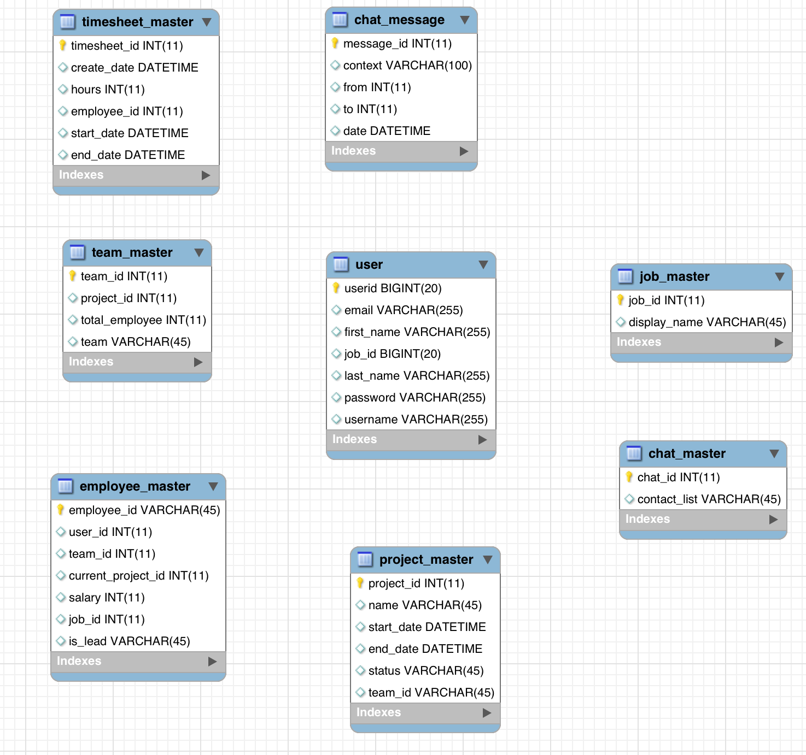

2.3 Class Diagram

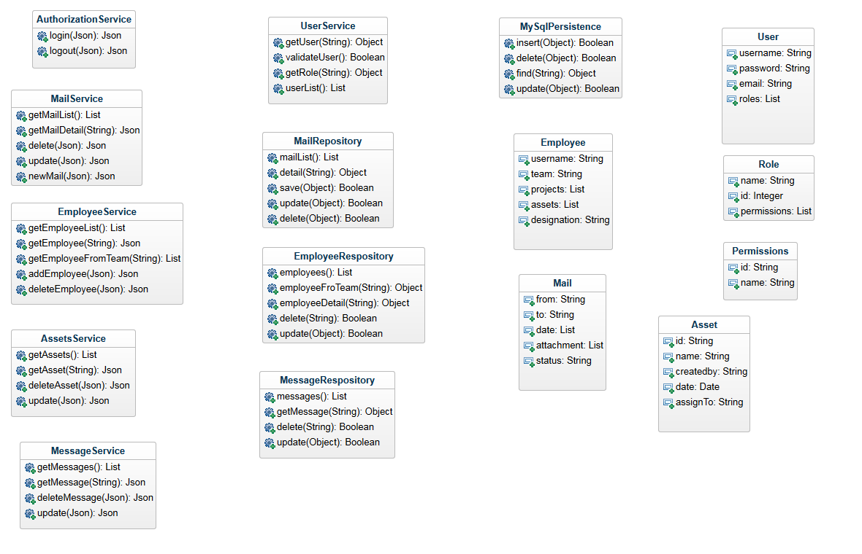

2.4 Data Flow Diagram

Validate Username and password from DB

Send username and password to Services

**User Login**

Login user based on token generated.

Send token back to client browser/ web server.

Check user details and create token

Request for Login.

**Database**

**Application Server**

**Web Server**

User

**Common Data flow:**

Request for data

Convert and display JSON data as html.

Required data for user in JSON format

Query data from Database

Validate login token from request and fetch required data from database

Return data to application server.

Send user request with login token to REST services

**Database**

**Application Server**

**Web Server**

User

System Design

3.1 Modularization

**3.1.1 Dojo Components**

Dojo Toolkit provides us flexibility to divide application in to small modules and widgets. Functionalities are divided into packages in dojo application. Every functionality in dojo application will be in a separate package/ folder. This folder will contain module code and html template file.

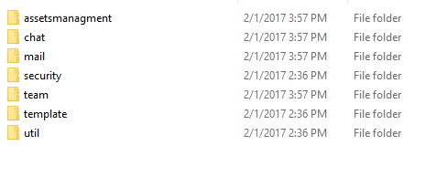

Every folder contains module js files and html templates. And will be loaded when needed from mail configuration file.

This will help to keep the application modular and will be easy to maintain and extend application functionality. Modules will be kept separate of each other and if need to add more modules then will be easy to add.

3.1.2 REST Components

REST Services are built using Java and Maven. Maven is a build tool for java based applications. This helps to maintain dependencies and project structure and also to divide project into multiple modules.

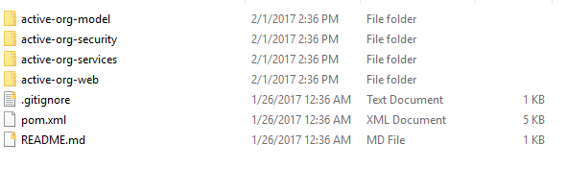

Pom.xml is a configuration file for maven build tool. This contains all the information about the modules we are using.

All the directories are separate modules and can use each other if needed.

3.2 Data Integrity & Design

3.2.1 Data Security

Security is handled in both REST and frontend application. The frontend application maintains a token, which is generated by services. And based on service validation it maintains user state. If this token is not valid then user will be asked for valid username and password and will not be able to access anything from front end. After getting valid username and password from user, it is passed to REST services to generate a token and validate user, if success then user will be granted with appropriate permissions based of the roles available in database.

Token Base Authentication

Information stored on websites varies widely in the amount of information which is available either publicly or privately. On some sites, a full-fledged database of personal information may be available -- from addresses and phone numbers to email and cha t contacts. On other sites, users may list only an email address and a website URL. More than that, sites may offer varying privacy levels for various sets of information. On Orkut, for example, users can set the level users must be in order to see each piece of information. This presents many issues when users of these sites want to start using FOAF for outside sources -- distributed data for profile information, or other similar means. Typical web-authentication is cookie-based, and offering a similar authentication to spiders or crawlers requires providing login information that most people would be reluctant to provide. (I certainly wouldn't want to give my password out to every website on the internet that asks for it.) There are solutions to this pa rticular problem, and in general, they aren't all that difficult to use. By adding authentication in a way that protects both the privacy of the user and their login information, you can increase the use of FOAF in remote applications.

No application wants to give out permanent access to user information. That type of access is more than most remote sites will ever need, in terms of both length of time and of the level of access. However, most sites are not designed to offer temporary viewing of resources. Thus, when users want to share resources - such as a FOAF file - between sites, they are forced to either save the information locally or deal without the information which the tool in question cannot see. When taking advantage of a tool's security levels, hosting a file locally completely defeats the purpose of the security levels in the first place. The solution to these problems is to offer temporary authentication via a non-password scheme. There are a number of possibilities as to how to perform this authentication technically. However, in order to perform distributed authentication while protecting both users privacy and passwords, the only way to authorize such authentication is via a token based authentication system.

The general concept behind a token-based authentication system is simple. Allow users to enter their username and password in order to obtain a token which allows them to fetch a specific resource - without using their username and password. Once their to ken has been obtained, the user can offer the token - which offers access to a specific resource for a time period - to the remote site. Using some form of authentication: a header, GET or POST request, or a cookie of some kind, the site can then determine what level of access the request in question should be afforded.

The type of changes this type of authentication requires is obviously dependent on the current implementation of your site. Example code I might be able to write in Perl or PHP would not only be language and implementation specific, it would also be application specific. However, some general principles should be considered in both the creation of a process to obtain tokens and the process of using them. Simplicity for users, robustness for interoperability, and protection of user data are all important f or your application, and each can fall by the wayside in attempting to design a system which fits user expectations.

A typical process for token based authentication would work as a communication between two sites: a remote site R and a base site, where the data is already stored, B. A user wishes to provide temporary authorization to site R to read his FOAF file at sit e B.

User selects "Import FOAF" or similar option

Site opens "Import FOAF" page, allowing user to select from a drop down selection of sites from which to import

User selects "Site B" from the list, and as a result, a box appears which allows the user to enter an authentication token. The site may optionally provide a link to the token creation page at this step to ease the task for the user.

User visits Site B Token Generation page. Once there, the user is asked for a username and password, as well as a resource to which site R should have access.

User receives authentication token from Site B, and copies token to form box on Site R.

Site R fetches the requested resource, using the authentication token in question. The token, rather than a typical cookie based authentication session, identifies the access level at which the site can obtain information.

There are a number of implementations which can be used to determine the access level, depending on the type of information which should be made available and what is currently available. The system I have the most knowledge in is LiveJournal, and as such, I will use that as an example of how to add token-based authentication to a resource.

LiveJournal has a number of security levels throughout the site. You can protect your entries to be readable to only you, only your friends, or up to 30 subgroups of your friends using unioned filters. However, this same level of protection and choice is not available to you when you are storing your profile information. Unlike Orkut, LiveJournal makes minimal options available for selecting the security of your profile information. Fortunately, for this example, this adds a level of simplicity not available in most cases.

When a request is received, LiveJournal passes the request to the FOAF creation instance, which then fetches the information unconditionally. Once the information has been retrieved, LiveJournal parses through the data manually and builds up a FOAF fil e based on the security options that are set. In order to add token based authentication to the system, we must add a check into the FOAF creation routine that allows us to override the "public" security available to most agents with a valid authentication key. In LiveJournal's case, to provide access to contact information at owner level, we need add only about 15 lines of code and a small MySQL table to store valid authentication keys. (A way to allow users to request such keys is not included in this code.) The attached diff file contains an example of how this works. As most of you will be able to understand, we are checking the offered authentication token against the tokens stored in the database within the past 24 hours. Although this is a relatively minimal example - LiveJournal has few security levels for profile data, and this change did not interfere in any way with existing APIs or functionality - it is obvious that in many cases, creating an authentication token backend is as simple as an extra if clause.

The frontend for using such an authentication system must be simple if users are to understand and use it. By providing the standard login template with a slightly modified interface to provide more information and documentation about authentication tokens, as well as the option to choose a resource specific resource, users can feel that they are in a similar environment - entering login data for the purpose of obtaining more specific information about themselves on the site in question. Once the information is verified, the user can then be offered a token which they can copy paste into another application, or perhaps the ability to have the token sent to a specific email address. Keep in mind, however, that these tokens offer, for a limited amount of time, a level of authentication, and in most cases, you will want to afford the same level of protection over these tokens: whether it be SSL encryption, or some other method - as you would over login information.

3.2.2 Design

Data is design as relational database. The design contains multiple tables and have relation between each other.

ER Diagram with relations and design:



3.3 Procedural Design

Start

Response with data requested as json

403 Response that will redirect to login

Valid Token

Invalid Token

Validate User

Response

Request

Database

Response in 403 Error

Get Data from DB

Validate User token

Request for Data

3.4 User Interface Diagram

dasdas

**Chat box**

**Notifications (List/detail)**

**Projects (List/ Detail)**

**Mail (List/ Detail)**

**Assets (List/ Detail)**

**Team (List/ Detail)**

**Dashboard**

**Login Form**

IMPLEMENTATION

4.1 Dojo Implementation

The dojoConfig object (known as djConfig prior to Dojo 1.6) is the primary mechanism for configuring Dojo in a web page or application. It is referenced by the module loader, as well as Dojo components with global options. It can further be used as a configuration point for custom applications, if desired.

The old object name of djConfig is deprecated, but any existing code using it will continue to work up until 2.0. At the time of writing, most documentation still uses djConfig; the two names are directly equivalent, but we'll adopt and encourage use of the new dojoConfig name from here on.

Code: /static/js/config.js

dojoConfig = {

has: {

"dojo-firebug": true,

"dojo-debug-messages": true

},

parseOnLoad: false,

baseUrl: "static/js",

packages: [

{ name: "dojo", location: "libs/dojo" },

{ name: "dijit", location: "libs/dijit" },

{ name: "dojox", location: "libs/dojox" },

{ name: "app", location: "app"}

]

};

Main file that will initialize configuration and all the components needed.

**Code: /static/js/init.js**

dojo.require("dojo.dom");

dojo.require("dojo.parser");

dojo.require("dijit.registry");

dojo.require("dojo.domReady!");

dojo.require("dijit.dijit");

dojo.require("dojo.html");

dojo.require("app.util.htmlUtil");

dojo.require("app.util.common");

dojo.require("app.security.login");

dojo.addOnLoad(function(){

//Parsing htmls with dojo components and widgets.

dojo.parser.parse();

//Bind click action to show login form

dojo.connect(app.util.htmlUtil.getById(app.util.common.CONS.userInfoNav), "onclick", function(e) {

app.util.htmlUtil.show( app.util.common.CONS.loginWrapper );

});

//Click function for close button for login form.

dojo.connect(app.util.htmlUtil.getById(app.util.common.CONS.closeLogin), "onclick", function(e) {

app.util.htmlUtil.hide( app.util.common.CONS.loginWrapper );

});

//Click function for login form submit

dojo.connect(app.util.htmlUtil.getById(app.util.common.login.submit), "onclick", function(e) {

app.security.login.requestLogin();

});

});

Security implementation for login handling:

**Code: /static/js/app/security/login.js**

define("app/security/login", [

"dojo/_base/declare",

"app/util/common",

"app/util/rest",

"app/util/htmlUtil",

"dojo/cookie"

], function(declare, common, rest, htmlUtil, cookie) {

var login = {

requestLogin : function() {

var response = rest.login( htmlUtil.getValue(common.login.usernameId) , htmlUtil.getValue(common.login.passwordId));

this.loginCallBack(response);

},

loginCallBack: function(response) {

if (response.status) {

//creating cookie to add login token cane in service response.

cookie("loginid", response.token, { expires: 10 });

htmlUtil.hide( common.CONS.loginWrapper );

} else {

//Showing error in case of invalid login.

console.log("error id: "+ common.CONS.loginErrorId)

htmlUtil.setHtml( common.CONS.loginErrorId, common.error.invalidLogin );

}

}

};

return login;

});

Main Html page to initiate page source:

**Code: /index.html**

**<!DOCTYPE html>**

**<html lang="en">**

**<head>**

**<title>Home</title>**

**<meta name="viewport" content="width=device-width, initial-scale=1.0">**

**<link href="https://fonts.googleapis.com/css?family=Raleway" rel="stylesheet">**

**<link rel="stylesheet" href="./static/css/claro/claro.css">**

**<link rel="stylesheet" href="./static/css/bootstrap.css">**

**<link rel="stylesheet" href="./static/css/font-awesome.min.css">**

**<link rel="stylesheet" href="./static/css/custom.css">**

**<script src="./static/js/config.js"></script>**

**<script src="./static/js/libs/dojo/dojo.js"></script>**

**<script src="./static/js/init.js"></script>**

**</head>**

**<body class="claro">**

**<div id="container">**

**<div class="row">**

**<section id="header">**

**<div class="col-xs-12 col-md-8" id="nav">**

**<nav id="mainNav">**

**<ul>**

**<li>**

**<a href="#" id="init-mail"><i class="fa fa-envelope"></i></a>**

**</li>**

**<li>**

**<a href="#" id="init-team"><i class="fa fa-users"></i></a>**

**</li>**

**<li>**

**<a href="#" id="init-assets"><i class="fa fa-th-large"></i></a>**

**</li>**

**<li>**

**<a href="#" id="init-projects"><i class="fa fa-sliders" aria-hidden="true"></i></a>**

**</li>**

**</ul>**

**</nav>**

**</div>**

**<div class="col-xs-6 col-md-4">**

**<nav id="userinfo">**

**<ul>**

**<li>**

**<a href="#" id="nav-notification"><i class="fa fa-bell" aria-hidden="true"></i></a>**

**</li>**

**<li>**

**<a href="#" id="nav-user" style="position: relative;"><i class="fa fa-user-circle"></i></a>**

**<div id="user-detail-nav" class="hide">**

**<p><a href="#" id="show-login">Login</a></p>**

**<p><a href="#" id="show-logout">Logout</a></p>**

**<p><a href="#" id="show-profile">Profile</a></p>**

**</div>**

**</li>**

**</ul>**

**</nav>**

**</div>**

**<div style="clear:both"></div>**

**</header>**

**<section id="breadcrums">**

**<p>Home</p>**

**</section>**

**</div>**

**<div class="row">**

**<div class="col-xs-12 col-md-12" id="main-content-section">**

**<div class="mail-module" data-dojo-type="app/mail/mailinit">**

**Loading...**

**</div>**

**<div class="assets-module" data-dojo-type="app/assetsmanagment/assetinit">**

**Loading...**

**</div>**

**<div class="team-module" data-dojo-type="app/team/teaminit">**

**Loading...**

**</div>**

**<div class="project-module" data-dojo-type="app/team/projectsinit">**

**Loading...**

**</div>**

**</div>**

**</div>**

**</div>**

**<div id="login-wrapper" class="hide">**

**<div class="row">**

**<div class="container">**

**<div id="login-form" class="col-md-4 col-md-offset-4">**

**<a href="#" id="close-login"><i class="fa fa-times" aria-hidden="true"></i></a>**

**<div class="form-group">**

**<label for="username">Username:</label>**

**<input type="text" class="form-control" name="username" id="username">**

**</div>**

**<div class="form-group">**

**<label for="password">Password:</label>**

**<input type="password" class="form-control" name="password" id="password">**

**</div>**

**<p class="error-message" id="login-error"></p>**

**<button type="button" class="btn btn-success" id="loginSubmit">Login</button>**

**</div>**

**</div>**

**</div>**

**</div>**

**</body>**

**</html>**

Basic html page with dojo is created. Now we have to create out modules and initialize them on this page:

1. Mail Module:

The mailinit.js file under app/mail folder is responsible to initialize this module. And this folder will also include html files that will contain templating for this module.

Templates will be under app/mail/html

**Code: app/mail/html/container.html**

**Sections will be divided like below:**

<div data-dojo-type="dijit/layout/BorderContainer" id="layoutContainer">

<div data-dojo-type="dijit/layout/ContentPane" data-dojo-props="region:'leading'" style="width: 200px;" class="col-md-4 side-tree">

<div id="mail-folders">

list of folders here

</div>

</div>

<div data-dojo-type="dijit/layout/ContentPane" data-dojo-props="region:'center'" class="col-md-6">

<div id="mail-list">

List here

</div>

<div data-dojo-type="dijit/layout/ContentPane" data-dojo-props="region:'bottom'">

<div id="mail-list">

detail here..

</div>

</div>

</div>

</div>

This will create two sections in this module. List section and a content section. List section will include folder listing for mails. And content section will include mail list and a section for detail view.

To add folders for mail we need to create memory store for dojo and initialize the tree widget for side section.

<div data-dojo-type="dojo/store/Memory" data-dojo-id="folderStore">

<script type="dojo/method">

this.setData([

{ id: 0, label: "folders"},

{id: 1, label: "Inbox", parent: 0},

{id: 2, label: "Sent", parent: 0},

{id: 3, label: "Trash", parent: 0},

{id: 4, label: "Draft", parent: 0}

]);

</script>

<script type="dojo/method" data-dojo-event="getChildren" data-dojo-args="object">

return this.query({parent: object.id});

</script>

</div>

These folder list will be displayed as below:

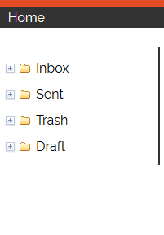

To initiate this we need to add:

<div data-dojo-type="dijit/tree/ObjectStoreModel" data-dojo-id="folderModel"

data-dojo-props="store: folderStore, query: {id: '0'}, labelAttr: 'label'"></div>

<div data-dojo-type="dijit/Tree" id="folderTree"

data-dojo-props="model: folderModel, showRoot: false">

<script type="dojo/method" data-dojo-event="onClick" data-dojo-args="item">

mailListTable.setQuery({

type: item.id,

folder: mailStore.getValue(item, "id")

});

</script>

</div>

To obtain list of mails we need to create a grid widget with a data store that contains all the mails detail.

<div data-dojo-type="dijit/layout/ContentPane" data-dojo-props="region:'top'">

<div id="mail-list">

<table data-dojo-type="dojox/grid/DataGrid" class="table table table-hover"

region="top" minSize="20" splitter="true"

data-dojo-id="mailListTable"

id="mailListTable"

store="mailStore" query="{ type: '1' }" style="height: 200px">

<thead>

<tr>

<th field="sender" width="10%">Sender</th>

<th field="label" width="80%">Subject</th>

<th field="sent" width="10%" formatter="formatDate">Date</th>

</tr>

</thead>

</table>

</div>

</div>

This will create a table view for mails list and we will bind a click action for these to get mail details and display it in detail view.

Mails will be fetched based on folder id in tree structure.

On clicking index it will fetch its id “1” and fetch all the mails that has type id 1

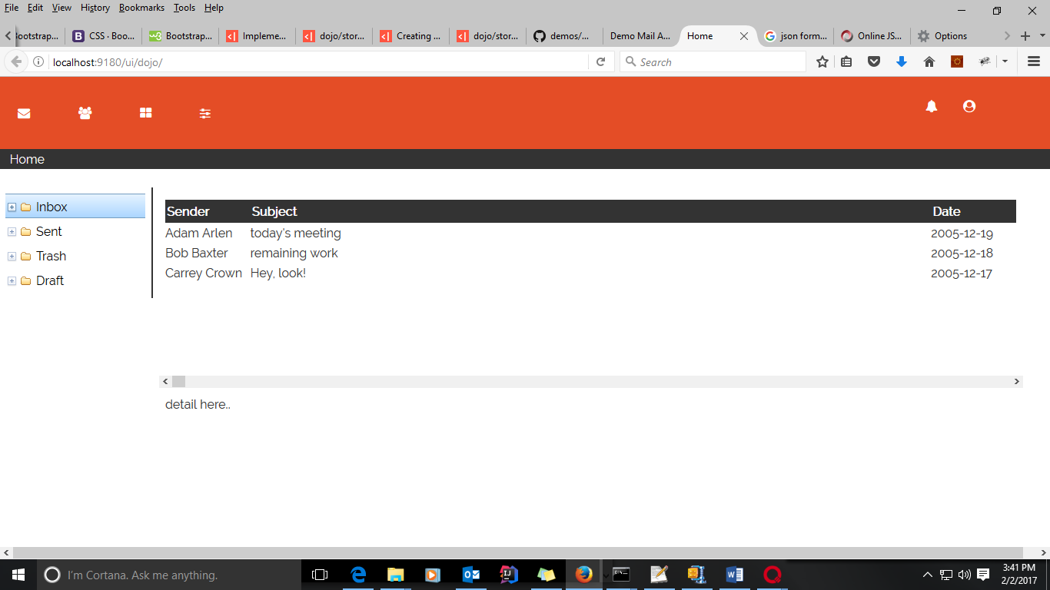

The mail list view will look like below screenshot:

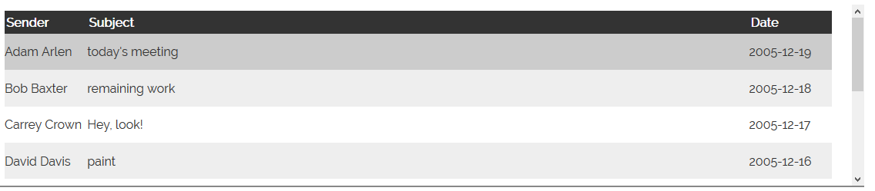

To bind click event for mail we need below snippet inside tablegrid section.

<script type="dojo/method" data-dojo-event="onRowClick" data-dojo-args="evt">

var rowData = this.getItem(evt.rowIndex);

showDetails(rowDate);

</script>

The detail section will look like this:

<div data-dojo-type="dijit/layout/ContentPane" data-dojo-props="region:'bottom'">

<div id="mail-detail">

<p><b>From: </b> <span id="from"> <span></p>

<p><b>Date: </b> <span id="date"><span></p>

<p><b>Sybject: </b> <span id="subject"><span></p>

<div id="detail">

</div>

</div>

</div>

The Html Section will look like this:

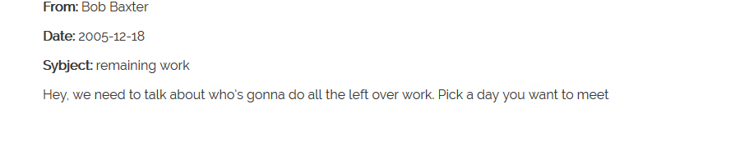

Finally the mail module page will look like below screenshot:

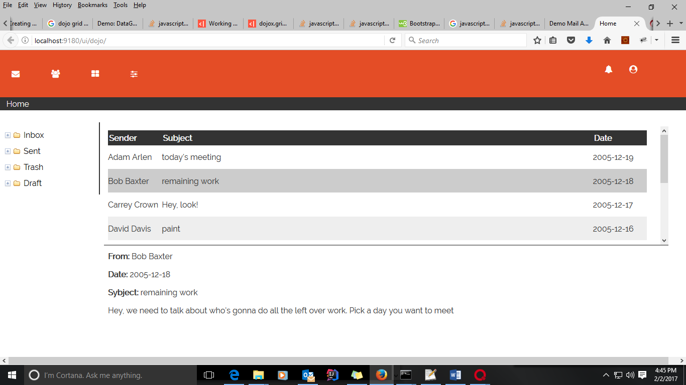

1. **Assets Module**

Assets management module will be placed under static\js\app\assetsmanagment directory. This will contain a js file to initialize the module and a template file that will contain all the presentation and flow for this module.

User can click on asset management icon from navigation to go to assets module.

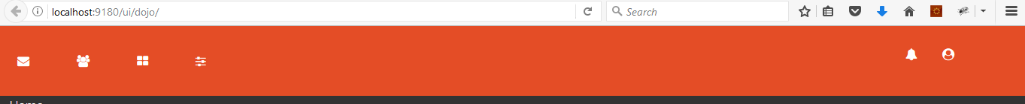

Icon to redirect user to assets management

Initialization for this module will be placed under assetsmanagment directory with name assetinit.js

**Code: static/js/app/assetsmanagment/assetinit.js**

define("app/assetsmanagment/assetinit", [

"dojo/_base/declare",

"dojo/store/Memory",

"dijit/tree/ObjectStoreModel",

"dijit/Tree",

"dijit/_WidgetBase",

"dojo/json",

"dijit/_OnDijitClickMixin",

"dijit/_TemplatedMixin",

"dijit/_WidgetsInTemplateMixin",

"dijit/form/Button",

"app/util/rest",

"dojo/text!./html/container.html"

], function(declare, Memory, ObjectStoreModel, Tree, _WidgetBase, json, _OnDijitClickMixin, _TemplatedMixin,

_WidgetsInTemplateMixin, Button,rest, template) {

return declare([_WidgetBase, _OnDijitClickMixin,

_TemplatedMixin, _WidgetsInTemplateMixin

], {

templateString: template

});

});

Template for this module will be under html directory. First we will divide all the section to place dynamic content.

**Code: static/js/app/assetsmanagment/html/container.html**

<div data-dojo-type="dijit/layout/BorderContainer" id="layoutContainer">

<div data-dojo-type="dijit/layout/ContentPane" data-dojo-props="region:'leading'" style="width: 200px;" class="col-md-4 side-tree">

<div id="assets-folders">

</div>

</div>

<div data-dojo-type="dijit/layout/ContentPane" data-dojo-props="region:'center'" class="col-md-10">

<div data-dojo-type="dijit/layout/ContentPane" data-dojo-props="region:'top'" style=" border-bottom: 2px solid #888; overflow-x: hidden;">

<div id="assets-list">

</div>

</div>

<div data-dojo-type="dijit/layout/ContentPane" data-dojo-props="region:'bottom'">

<div id="asset-detail">

</div>

</div>

</div>

</div>

We will get list of all the assets assigned to employees and assets used in office. To get list of all assets and place it as a tree structure we need to create a memory store.

**Code:** **static/js/app/assetsmanagment/html/container.html**

<div data-dojo-type="dojo/data/ItemFileWriteStore" data-dojo-id="assetsListStore"

url="http:localhost:8080/rest/assets"></div>

This will get all the list from rest service URL.

To place this list as a tree structure we need to update our code to:

<div data-dojo-type="dijit/tree/ObjectStoreModel" data-dojo-id="assetsFolderModel"

data-dojo-props="store: assetsListStore, query: {id: '0'}, labelAttr: 'label'"></div>

<div data-dojo-type="dijit/Tree" id="folderTree"

data-dojo-props="model: assetsFolderModel, showRoot: false">

<script type="dojo/method" data-dojo-event="onClick" data-dojo-args="item">

assetsListTable.setQuery({

assigned: item.id,

folder: assetsListStore.getValue(item, "id")

});

</script>

</div>

This will create structure displayed in below screenshot:

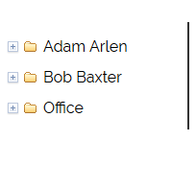

This will list all the employees and common office assets. After clicking on any name we will be able to see all the assets list for that employee.

Now we will get list of all the assets under selected employee.

To add this we need to create a grid view that will filter the assets list on click.

**Code:** **static/js/app/assetsmanagment/html/container.html**

<table data-dojo-type="dojox/grid/DataGrid" class="table table table-hover"

region="top" minSize="20" splitter="true"

data-dojo-id=" assetsListTable "

id="assetsListTable"

store="assetListStore" query="{ type: '1' }" style="height: 200px">

<thead>

<tr>

<th field="name" width="10%">Name</th>

<th field="date" width="80%">Date</th>

<th field="status" >Status</th>

</tr>

</thead>

</table>

Above change will look like below screenshot:

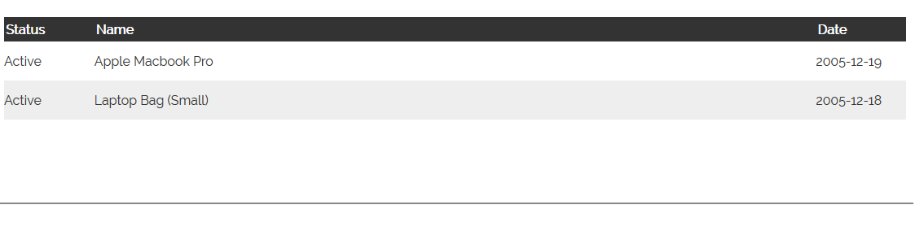

To bind click event for asset we need below snippet inside table grid section.

**Code:** **static/js/app/assetsmanagment/html/container.html**

<script type="dojo/method" data-dojo-event="onRowClick" data-dojo-args="evt">

var rowData = this.getItem(evt.rowIndex);

showAssetDetails(rowDate);

</script>

The detail section in this module will contain a form where user can update the assets information.

**Code:** **static/js/app/assetsmanagment/html/container.html**

<div class="col-md-6">

<div class="form-group">

<label for="name">Name:</label>

<input class="form-control" name="name" id="name" type="text">

</div>

<div class="form-group">

<label for="date">Date:</label>

<input class="form-control" name="date" id="date" type="text">

</div>

<div class="form-group">

<label for="assigned">Assigned To:</label>

<input class="form-control" name="assigned" id="assigned" type="text">

</div>

<div class="form-group">

<select name="status" class="form-control">

<option value="active">active</option>

<option value="inactive">InActive</option>

</select>

</div>

</div>

This will be displayed as presented in screenshots below:

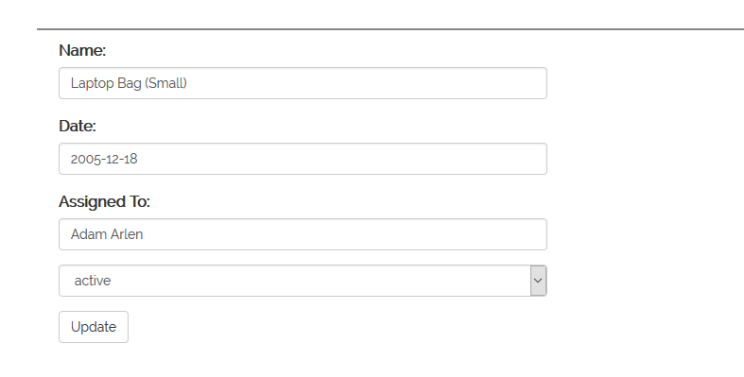

At the end our module page will look like below Screenshot:

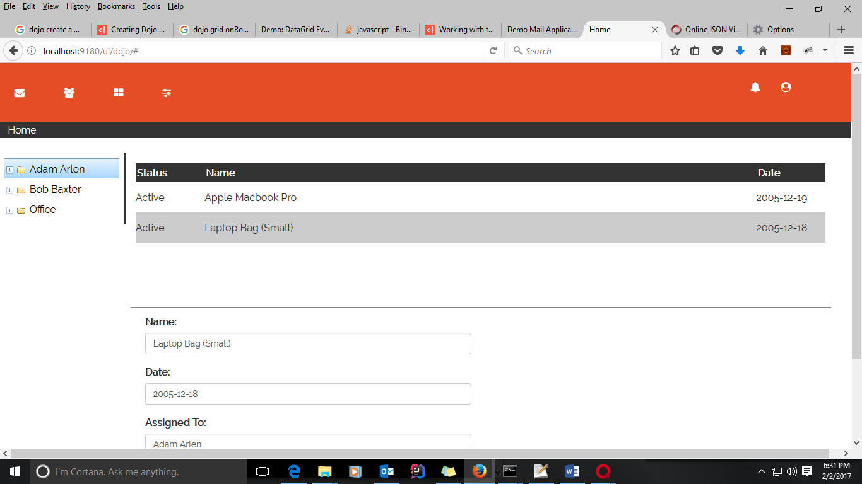

1. **Team Management:**

Team management module will be placed under static\js\app\team directory. This will contain a js file to initialize the module and a template file that will contain all the presentation and flow for this module.

User can click on team management icon from navigation to go to team module.



Icon to redirect user to team management

Initialization for this module will be placed under team directory with name teaminit.js

**Code: static/js/app/team/teaminit.js**

define("app/team/teaminit", [

"dojo/_base/declare",

"dojo/store/Memory",

"dijit/tree/ObjectStoreModel",

"dijit/Tree",

"dijit/_WidgetBase",

"dojo/json",

"dijit/_OnDijitClickMixin",

"dijit/_TemplatedMixin",

"dijit/_WidgetsInTemplateMixin",

"dijit/form/Button",

"app/util/rest",

"dojo/text!./html/container.html"

], function(declare, Memory, ObjectStoreModel, Tree, _WidgetBase, json, _OnDijitClickMixin, _TemplatedMixin,

_WidgetsInTemplateMixin, Button,rest, template) {

return declare([_WidgetBase, _OnDijitClickMixin,

_TemplatedMixin, _WidgetsInTemplateMixin

], {

templateString: template

});

});

Template for this module will be under html directory. First we will divide all the section to place dynamic content

**Code: static/js/app/team/html/container.html**

<div data-dojo-type="dijit/layout/BorderContainer" id="layoutContainer">

<div data-dojo-type="dijit/layout/ContentPane" data-dojo-props="region:'leading'" style="width: 200px;" class="col-md-4 side-tree">

<div id="team-folders">

</div>

</div>

<div data-dojo-type="dijit/layout/ContentPane" data-dojo-props="region:'center'" class="col-md-10">

<div data-dojo-type="dijit/layout/ContentPane" data-dojo-props="region:'top'" style=" border-bottom: 2px solid #888; overflow-x: hidden;">

<div id="employee-list">

</div>

</div>

<div data-dojo-type="dijit/layout/ContentPane" data-dojo-props="region:'bottom'">

<div id="employee-detail">

</div>

</div>

</div>

</div>

We will get list of all the teams that have number of employees assigned. To get list of all teams and place it as a tree structure we need to create a memory store.

**Code: static/js/app/team/html/container.html**

<div data-dojo-type="dojo/data/ItemFileWriteStore" data-dojo-id="teamListStore"

url="http:localhost:8080/rest/teams"></div>

This will get all the list from rest service URL

To place this list as a tree structure we need to update our code to

<div data-dojo-type="dijit/tree/ObjectStoreModel" data-dojo-id="teamFolderModel"

data-dojo-props="store: teamListStore, query: {id: '0'}, labelAttr: 'label'"></div>

<div data-dojo-type="dijit/Tree" id="folderTree"

data-dojo-props="model: teamFolderModel, showRoot: false">

<script type="dojo/method" data-dojo-event="onClick" data-dojo-args="item">

employeeListTable.setQuery({

id: item.id,

folder: teamListStore.getValue(item, "id")

});

</script>

</div>

This will create structure displayed in below screenshot:

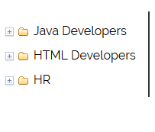

This will list all the teams present in database. We will bind each team item with a function that will be execute on click and will list all the employees available in that team.

To add this we need to create a grid view that will filter the employee list on click.

**Code:** **static/js/app/team/html/container.html**

<table data-dojo-type="dojox/grid/DataGrid" class="table table table-hover"

region="top" minSize="20" splitter="true"

data-dojo-id="employeeListTable "

id="employeeListTable "

store="teamListStore" query="{ type: '1' }" style="height: 200px">

<thead>

<tr>

<th field="name" width="10%">Name</th>

<th field="date" width="20%">From</th>

<th field="year" width="20%">Experience</th>

<th field="status" >Status</th>

</tr>

</thead>

</table>

Above change will look like below screenshot:

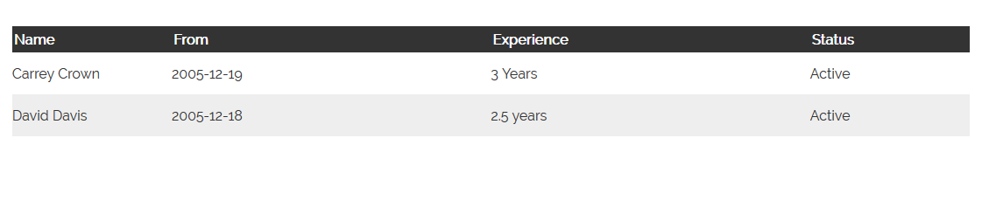

To bind click event for each employee in list we need below snippet inside table grid section.

**Code:** **static/js/app/assetsmanagment/html/container.html**

<script type="dojo/method" data-dojo-event="onRowClick" data-dojo-args="evt">

var rowData = this.getItem(evt.rowIndex);

showEmployeeDetails(rowDate);

</script>

The detail section in this module will contain employee information and an option to remove that employee from team.

<div class="col-md-12">

<p><b>Name: </b> <span id="name"> <span></p>

<p><b>From: </b> <span id="date"><span></p>

<p><b>Experience: </b> <span id="exprs"> <span></p>

<div data-dojo-type="dijit/form/Button">

<script type="dojo/on" data-dojo-event="click" data-dojo-args="evt">

require(["app/util/rest"], function(rest){

rest.post("http://localhost:8080/rest/team/remove, {"employee", employee.id});

});

</script>

Remove

</div>

</div>

This will create a detail view like below screenshot:

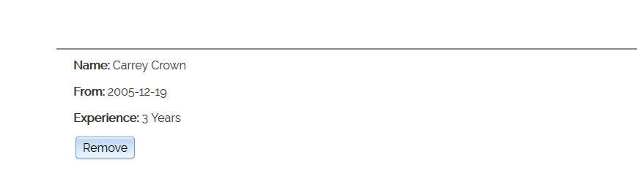

In Above code we have added an inline function for remove click event that will be executed to remove that employee from that team.

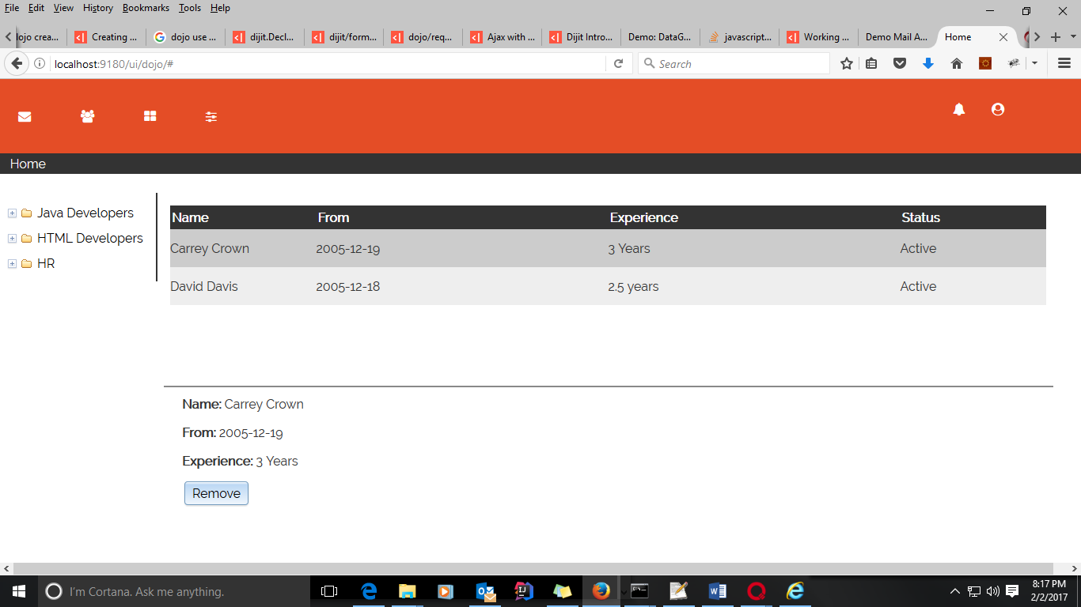

1. **Project Management**

Project management module will be placed under static\js\app\team directory. This will contain a js file to initialize the module and a template file that will contain all the presentation and flow for this module.

User can click on project management icon from navigation to go to project module.



Icon to redirect user to team management

Initialization for this module will be placed under team directory with name projectinit.js

**Code: static/js/app/team/projectinit.js**

define("app/team/projectinit", [

"dojo/_base/declare",

"dojo/store/Memory",

"dijit/tree/ObjectStoreModel",

"dijit/Tree",

"dijit/_WidgetBase",

"dojo/json",

"dijit/_OnDijitClickMixin",

"dijit/_TemplatedMixin",

"dijit/_WidgetsInTemplateMixin",

"dijit/form/Button",

"app/util/rest",

"dojo/text!./html/container.html"

], function(declare, Memory, ObjectStoreModel, Tree, _WidgetBase, json, _OnDijitClickMixin, _TemplatedMixin,

_WidgetsInTemplateMixin, Button,rest, template) {

return declare([_WidgetBase, _OnDijitClickMixin,

_TemplatedMixin, _WidgetsInTemplateMixin

], {

templateString: template

});

});

Template for this module will be under html directory. First we will divide all the section to place dynamic content.

<div data-dojo-type="dijit/layout/BorderContainer" id="layoutContainer">

<div data-dojo-type="dijit/layout/ContentPane" data-dojo-props="region:'leading'" style="width: 200px;" class="col-md-4 side-tree">

<div id="project-folders">

</div>

</div>

<div data-dojo-type="dijit/layout/ContentPane" data-dojo-props="region:'center'" class="col-md-10">

<div id="project-details">

</div>

</div>

</div>

First we will fetch all the projects from Database.

To place this list as a tree structure we need to update our code to

<div data-dojo-type="dojo/data/ItemFileWriteStore" data-dojo-id="projectListStore"

url="http:localhost:8080/rest/projects"></div>

<div data-dojo-type="dijit/tree/ObjectStoreModel" data-dojo-id="projectFolderModel"

data-dojo-props="store: projectListStore, query: {id: '0'}, labelAttr: 'label'"></div>

<div data-dojo-type="dijit/Tree" id="folderTree"

data-dojo-props="model: projectFolderModel, showRoot: false">

<script type="dojo/method" data-dojo-event="onClick" data-dojo-args="item">

//Fetch project details

</script>

</div>

This will create structure displayed in below screenshot:

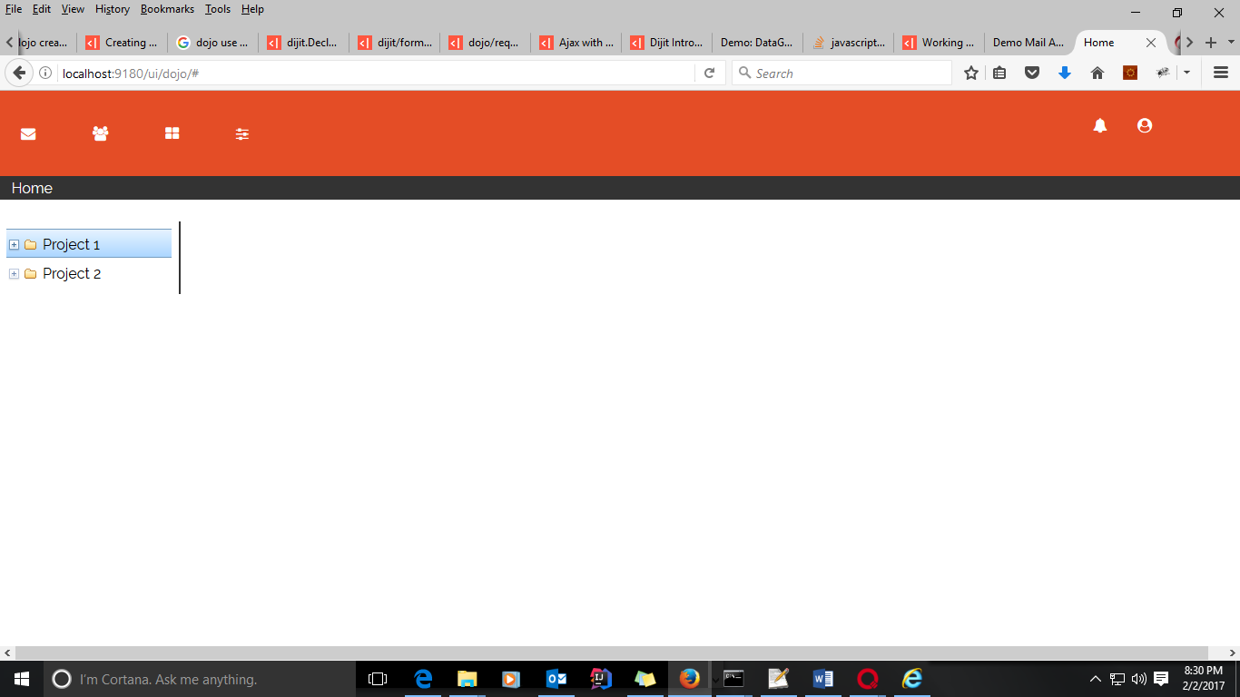

This will list all the projects present in database. We will bind each project item with a function that will be execute on click and will list all the details available in that project.

Now we will add a function on project click event and fetch all the detail for that project.

require(["app/util/rest", "app/util/htmlUtil"], function(rest, htmlUtil){

var projectData = rest.get("http://localhost:8080/rest/team/project" + item.id);

var html = "<div>";

html = html + "<p><b>Project Id: </b> <span>+ projectData.id +"<span></p>";

html = html + "<p><b>Team: </b> <span>+ projectData.team.name +"<span></p>";

html = html + "<p><b>Status: </b> <span>+ projectData.status +"<span></p>";

html = html + "</div>";

htmlUtil.setHtml("#project-details", html);

});

Above script will be placed at comment **Fetch project details** and it will be executed after click on any project from right structure.

At the end our module will look like:

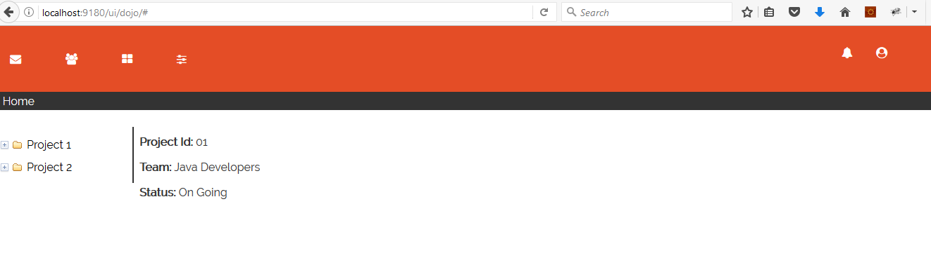

4.1 Dojo Implementation

REST services are written in java and it uses Maven to build all the source code and create a war file, which will be deployed in an application container.

Maven Module:

There are four module in this source code:

* 1. active-org-model
  2. active-org-security
  3. active-org-services
  4. active-org-web

The modules are managed by a parent pom.xml configuration. So the structure will be like below: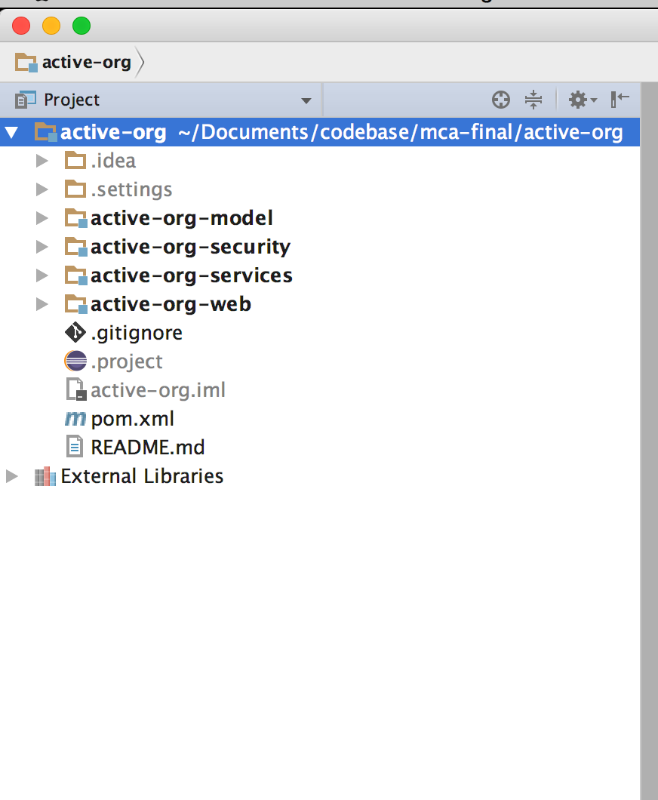

Main pom.xml

<project xmlns="http://maven.apache.org/POM/4.0.0"

xmlns:xsi="http://www.w3.org/2001/XMLSchema-instance"

xsi:schemaLocation="http://maven.apache.org/POM/4.0.0

http://maven.apache.org/maven-v4_0_0.xsd">

<modelVersion>4.0.0</modelVersion>

<groupId>org.active.parent</groupId>

<artifactId>active-org</artifactId>

<packaging>pom</packaging>

<version>1.0</version>

<name>Active Organisation Parent Pom</name>

<properties>

<java.version>1.8</java.version>

<maven.compile.version>3.5.1</maven.compile.version>

</properties>

<modules>

<module>active-org-services</module>

<module>active-org-model</module>

<module>active-org-web</module>

<module>active-org-security</module>

</modules>

<dependencyManagement>

<dependencies>

<dependency>

<groupId>javax.servlet</groupId>

<artifactId>javax.servlet-api</artifactId>

<version>3.1.0</version>

<scope>provided</scope>

</dependency>

<dependency>

<groupId>junit</groupId>

<artifactId>junit</artifactId>

<version>3.8.1</version>

<scope>test</scope>

</dependency>

<dependency>

<groupId>log4j</groupId>

<artifactId>log4j</artifactId>

<version>1.2.17</version>

</dependency>

<!-- Apache libraries -->

<dependency>

<groupId>org.apache.commons</groupId>

<artifactId>commons-lang3</artifactId>

<version>3.0</version>

</dependency>

<!--Jersey Libs-->

<dependency>

<groupId>org.glassfish.jersey.core</groupId>

<artifactId>jersey-server</artifactId>

<version>2.24</version>

</dependency>

<dependency>

<groupId>org.glassfish.jersey.containers</groupId>

<artifactId>jersey-container-servlet</artifactId>

<version>2.24</version>

</dependency>

<!-- https://mvnrepository.com/artifact/javax.xml.bind/jaxb-api -->

<dependency>

<groupId>javax.xml.bind</groupId>

<artifactId>jaxb-api</artifactId>

<version>2.1</version>

</dependency>

<!-- https://mvnrepository.com/artifact/javax.xml/jaxb-api -->

<dependency>

<groupId>javax.xml</groupId>

<artifactId>jaxb-api</artifactId>

<version>2.1</version>

</dependency>

<!-- https://mvnrepository.com/artifact/javax.xml/jaxb-impl -->

<dependency>

<groupId>javax.xml</groupId>

<artifactId>jaxb-impl</artifactId>

<version>2.1</version>

</dependency>

<!-- https://mvnrepository.com/artifact/com.eclipsesource.minimal-json/minimal-json -->

<dependency>

<groupId>com.eclipsesource.minimal-json</groupId>

<artifactId>minimal-json</artifactId>

<version>0.9.4</version>

</dependency>

<dependency>

<groupId>commons-io</groupId>

<artifactId>commons-io</artifactId>

<version>2.5</version>

</dependency>

<dependency>

<groupId>org.hibernate</groupId>

<artifactId>hibernate-core</artifactId>

<version>5.2.1.Final</version>

</dependency>

<dependency>

<groupId>mysql</groupId>

<artifactId>mysql-connector-java</artifactId>

<version>5.1.37</version>

</dependency>

<!-- Apache Codec -->

<dependency>

<groupId>commons-codec</groupId>

<artifactId>commons-codec</artifactId>

<version>1.10</version>

</dependency>

</dependencies>

</dependencyManagement>

<build>

<plugins>

<plugin>

<groupId>org.apache.maven.plugins</groupId>

<artifactId>maven-compiler-plugin</artifactId>

<version>${maven.compile.version}</version>

<configuration>

<target>${java.version}</target>

<source>${java.version}</source>

</configuration>

</plugin>

<plugin>

<groupId>org.apache.tomcat.maven</groupId>

<artifactId>tomcat7-maven-plugin</artifactId>

<version>2.2</version>

<configuration>

<url>http://localhost:8080/manager/text</url>

<server>active-org</server>

<path>/active-org</path>

<skip>true</skip>

</configuration>

</plugin>

</plugins>

</build>

</project>

Every module will contain a pom.xml and will define its dependencies and their module id (artifactid)

active-org-model/pom.xml

<?xml version="1.0" encoding="UTF-8"?>

<project xmlns="http://maven.apache.org/POM/4.0.0"

xmlns:xsi="http://www.w3.org/2001/XMLSchema-instance"

xsi:schemaLocation="http://maven.apache.org/POM/4.0.0 http://maven.apache.org/xsd/maven-4.0.0.xsd">

<parent>

<artifactId>active-org</artifactId>

<groupId>org.active.parent</groupId>

<version>1.0</version>

</parent>

<modelVersion>4.0.0</modelVersion>

<artifactId>active-org-model</artifactId>

<packaging>jar</packaging>

<dependencies>

<dependency>

<groupId>org.hibernate</groupId>

<artifactId>hibernate-core</artifactId>

</dependency>

<dependency>

<groupId>mysql</groupId>

<artifactId>mysql-connector-java</artifactId>

</dependency>

<dependency>

<groupId>log4j</groupId>

<artifactId>log4j</artifactId>

</dependency>

</dependencies>

</project>

active-org-security/pom.xml

<?xml version="1.0" encoding="UTF-8"?>

<project xmlns="http://maven.apache.org/POM/4.0.0"

xmlns:xsi="http://www.w3.org/2001/XMLSchema-instance"

xsi:schemaLocation="http://maven.apache.org/POM/4.0.0 http://maven.apache.org/xsd/maven-4.0.0.xsd">

<parent>

<artifactId>active-org</artifactId>

<groupId>org.active.parent</groupId>

<version>1.0</version>

</parent>

<modelVersion>4.0.0</modelVersion>

<artifactId>active-org-security</artifactId>

<packaging>jar</packaging>

<dependencies>

<dependency>

<groupId>javax.servlet</groupId>

<artifactId>javax.servlet-api</artifactId>

</dependency>

<dependency>

<groupId>log4j</groupId>

<artifactId>log4j</artifactId>

</dependency>

<dependency>

<groupId>commons-codec</groupId>

<artifactId>commons-codec</artifactId>

</dependency>

<dependency>

<groupId>com.eclipsesource.minimal-json</groupId>

<artifactId>minimal-json</artifactId>

</dependency>

</dependencies>

</project>

active-org-services/pom.xml

<?xml version="1.0" encoding="UTF-8"?>

<project xmlns="http://maven.apache.org/POM/4.0.0"

xmlns:xsi="http://www.w3.org/2001/XMLSchema-instance"

xsi:schemaLocation="http://maven.apache.org/POM/4.0.0 http://maven.apache.org/xsd/maven-4.0.0.xsd">

<parent>

<artifactId>active-org</artifactId>

<groupId>org.active.parent</groupId>

<version>1.0</version>

</parent>

<modelVersion>4.0.0</modelVersion>

<artifactId>active-org-services</artifactId>

<packaging>jar</packaging>

<dependencies>

<dependency>

<groupId>org.reflections</groupId>

<artifactId>reflections</artifactId>

<version>0.9.10</version>

</dependency>

<dependency>

<groupId>log4j</groupId>

<artifactId>log4j</artifactId>

</dependency>

<dependency>

<groupId>org.active.parent</groupId>

<artifactId>active-org-model</artifactId>

<version>1.0</version>

</dependency>

</dependencies>

</project>

active-org-web/pom.xml

<?xml version="1.0" encoding="UTF-8"?>

<project xmlns="http://maven.apache.org/POM/4.0.0"

xmlns:xsi="http://www.w3.org/2001/XMLSchema-instance"

xsi:schemaLocation="http://maven.apache.org/POM/4.0.0 http://maven.apache.org/xsd/maven-4.0.0.xsd">

<parent>

<artifactId>active-org</artifactId>

<groupId>org.active.parent</groupId>

<version>1.0</version>

</parent>

<modelVersion>4.0.0</modelVersion>

<artifactId>active-org-web</artifactId>

<packaging>war</packaging>

<dependencies>

<dependency>

<groupId>javax.servlet</groupId>

<artifactId>javax.servlet-api</artifactId>

</dependency>

<dependency>

<groupId>log4j</groupId>

<artifactId>log4j</artifactId>

</dependency>

<dependency>

<groupId>commons-io</groupId>

<artifactId>commons-io</artifactId>

</dependency>

<!--Jersey Libs-->

<dependency>

<groupId>org.glassfish.jersey.core</groupId>

<artifactId>jersey-server</artifactId>

</dependency>

<dependency>

<groupId>org.glassfish.jersey.containers</groupId>

<artifactId>jersey-container-servlet</artifactId>

</dependency>

<dependency>

<groupId>javax.xml.bind</groupId>

<artifactId>jaxb-api</artifactId>

</dependency>

<dependency>

<groupId>javax.xml</groupId>

<artifactId>jaxb-api</artifactId>

</dependency>

<dependency>

<groupId>javax.xml</groupId>

<artifactId>jaxb-impl</artifactId>

</dependency>

<dependency>

<groupId>com.eclipsesource.minimal-json</groupId>

<artifactId>minimal-json</artifactId>

</dependency>

<dependency>

<groupId>org.active.parent</groupId>

<artifactId>active-org-services</artifactId>

<version>1.0</version>

</dependency>

<dependency>

<groupId>org.active.parent</groupId>

<artifactId>active-org-security</artifactId>

<version>1.0</version>

</dependency>

</dependencies>

<build>

<finalName>ROOT</finalName>

<plugins>

<plugin>

<groupId>org.apache.maven.plugins</groupId>

<artifactId>maven-war-plugin</artifactId>

<version>3.0.0</version>

<configuration>

<failOnMissingWebXml>false</failOnMissingWebXml>

</configuration>

</plugin>

<plugin>

<groupId>org.apache.tomcat.maven</groupId>

<artifactId>tomcat7-maven-plugin</artifactId>

<version>2.2</version>

<configuration>

<url>http://localhost:8080/manager/text</url>

<server>active-org</server>

<path>/</path>

</configuration>

</plugin>

</plugins>

</build>

</project>

* 1. active-org-model

This module contains all the entities related to mysql database ex: User, Role, Project etc which will be a java pojo representation for mysql tables. And this module will contain session initialisation for mysql connection.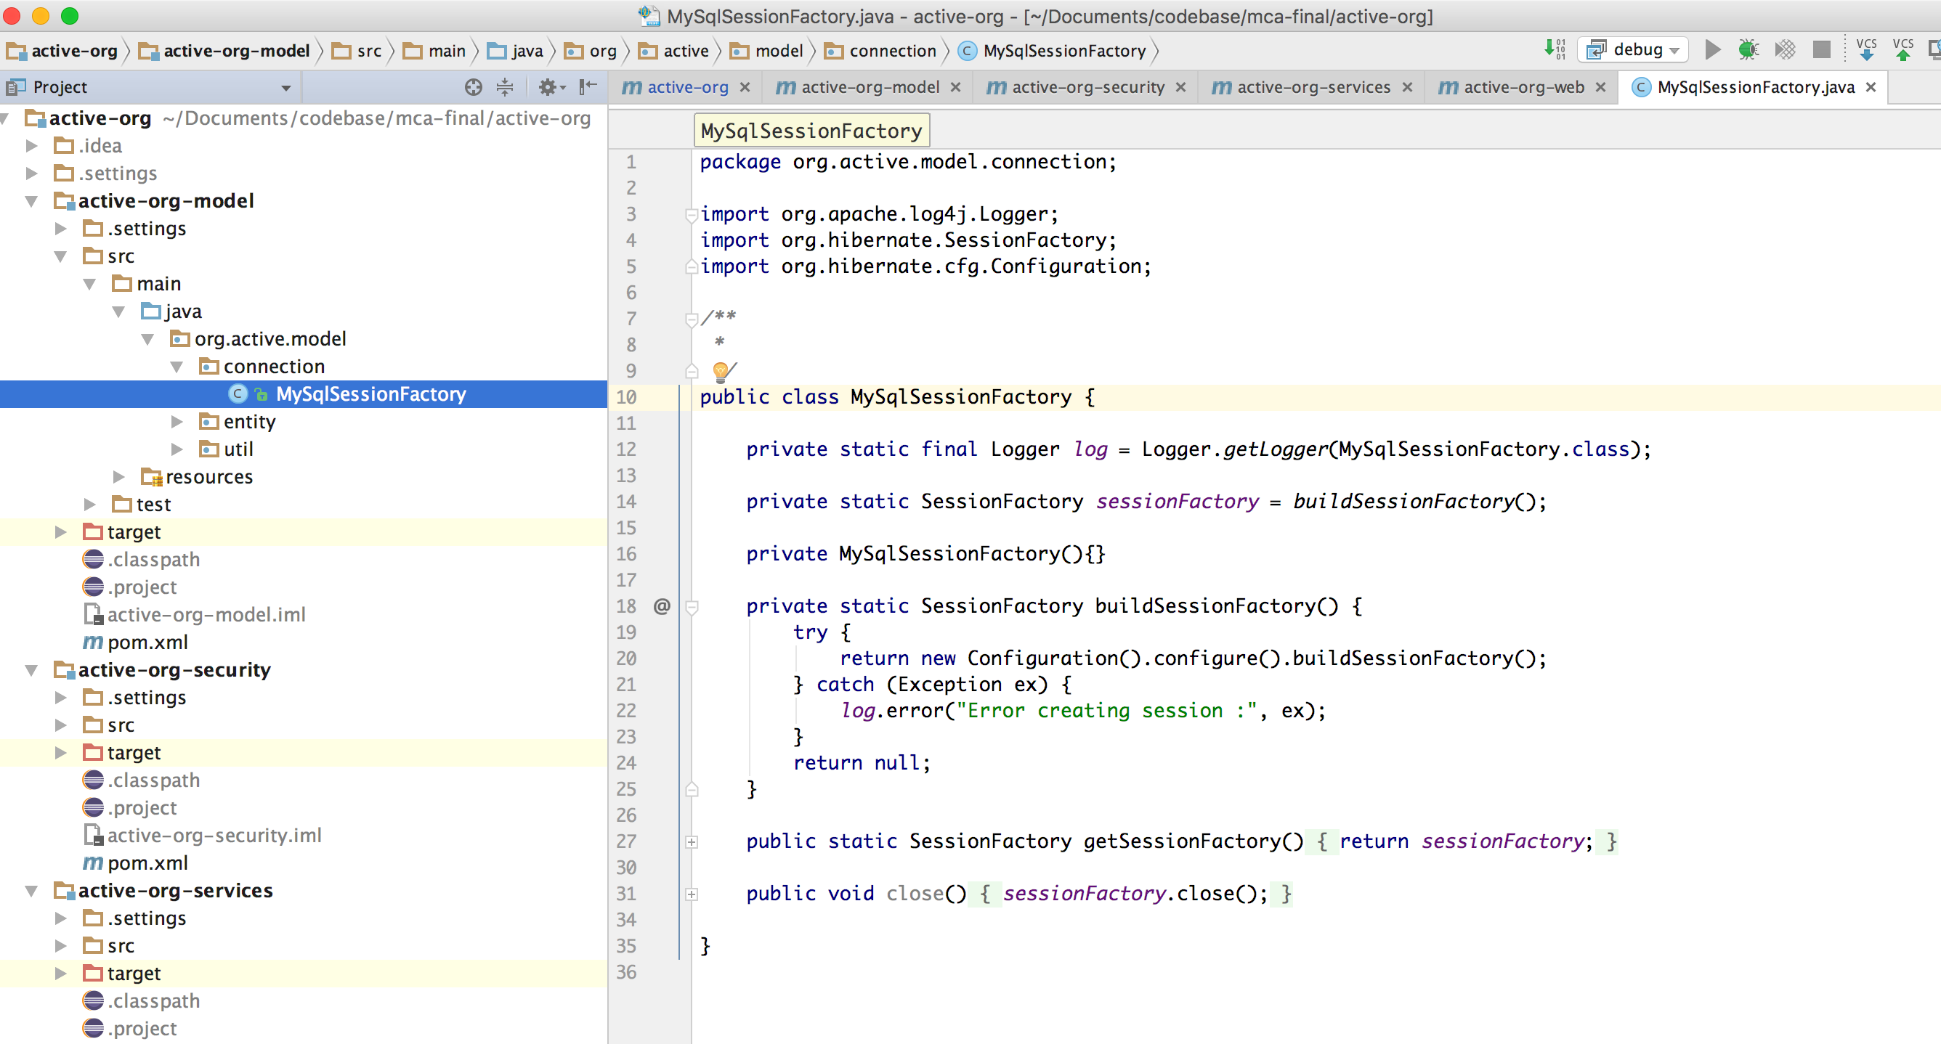

MySqlSessionFactory is a factory class that provides mysql database connection to perform persistence operations.

This module contains entity package that contains all the entity classes.

Code : User.java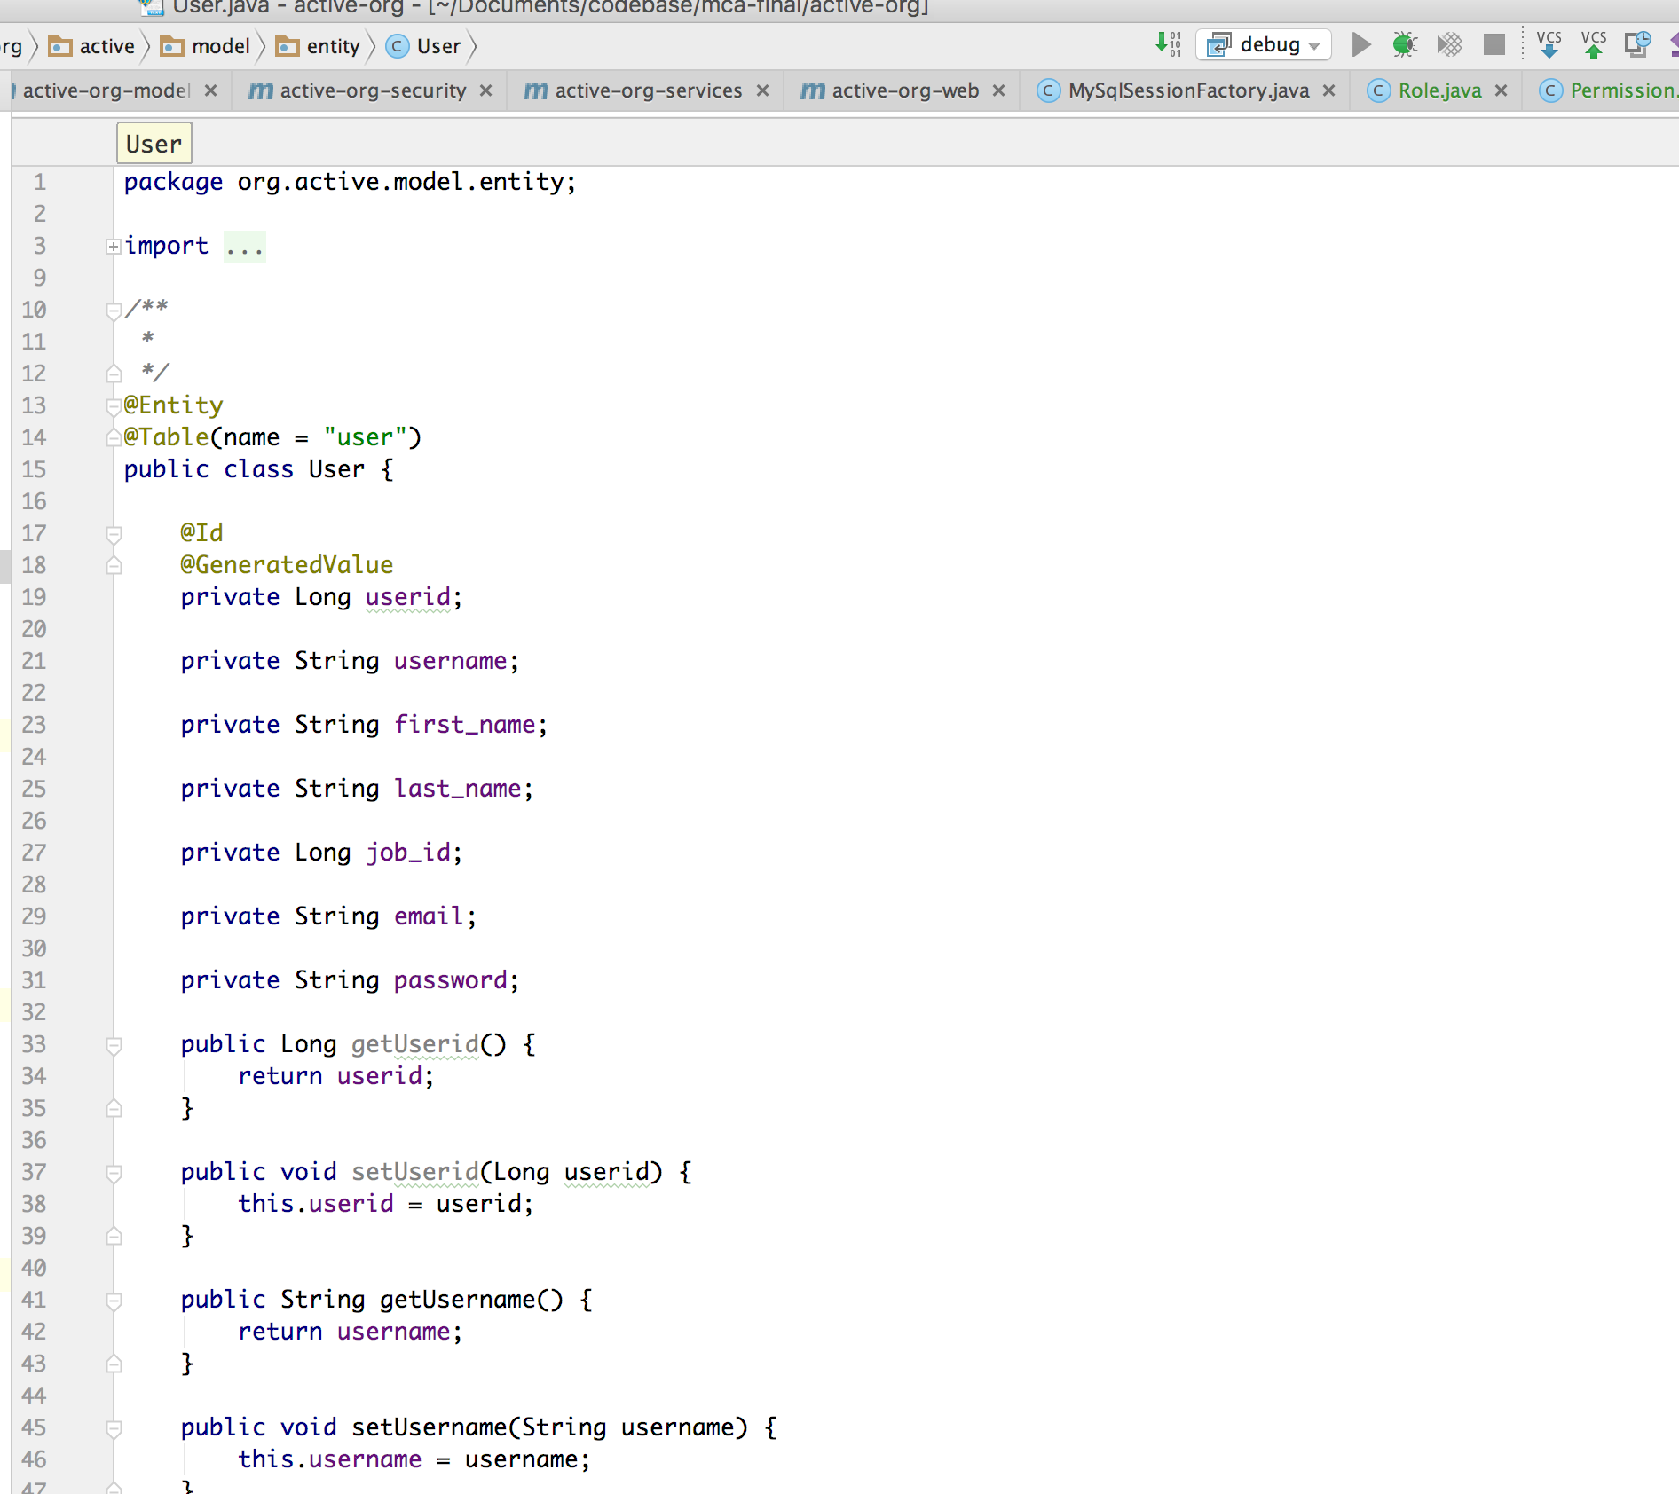

@Entity annotation here represents this class as a mysql pojo mapping class. @Table maps this class to a mysql table, what ever name we give for name in this annotation.

Entity class for Employee entity:

2. active-o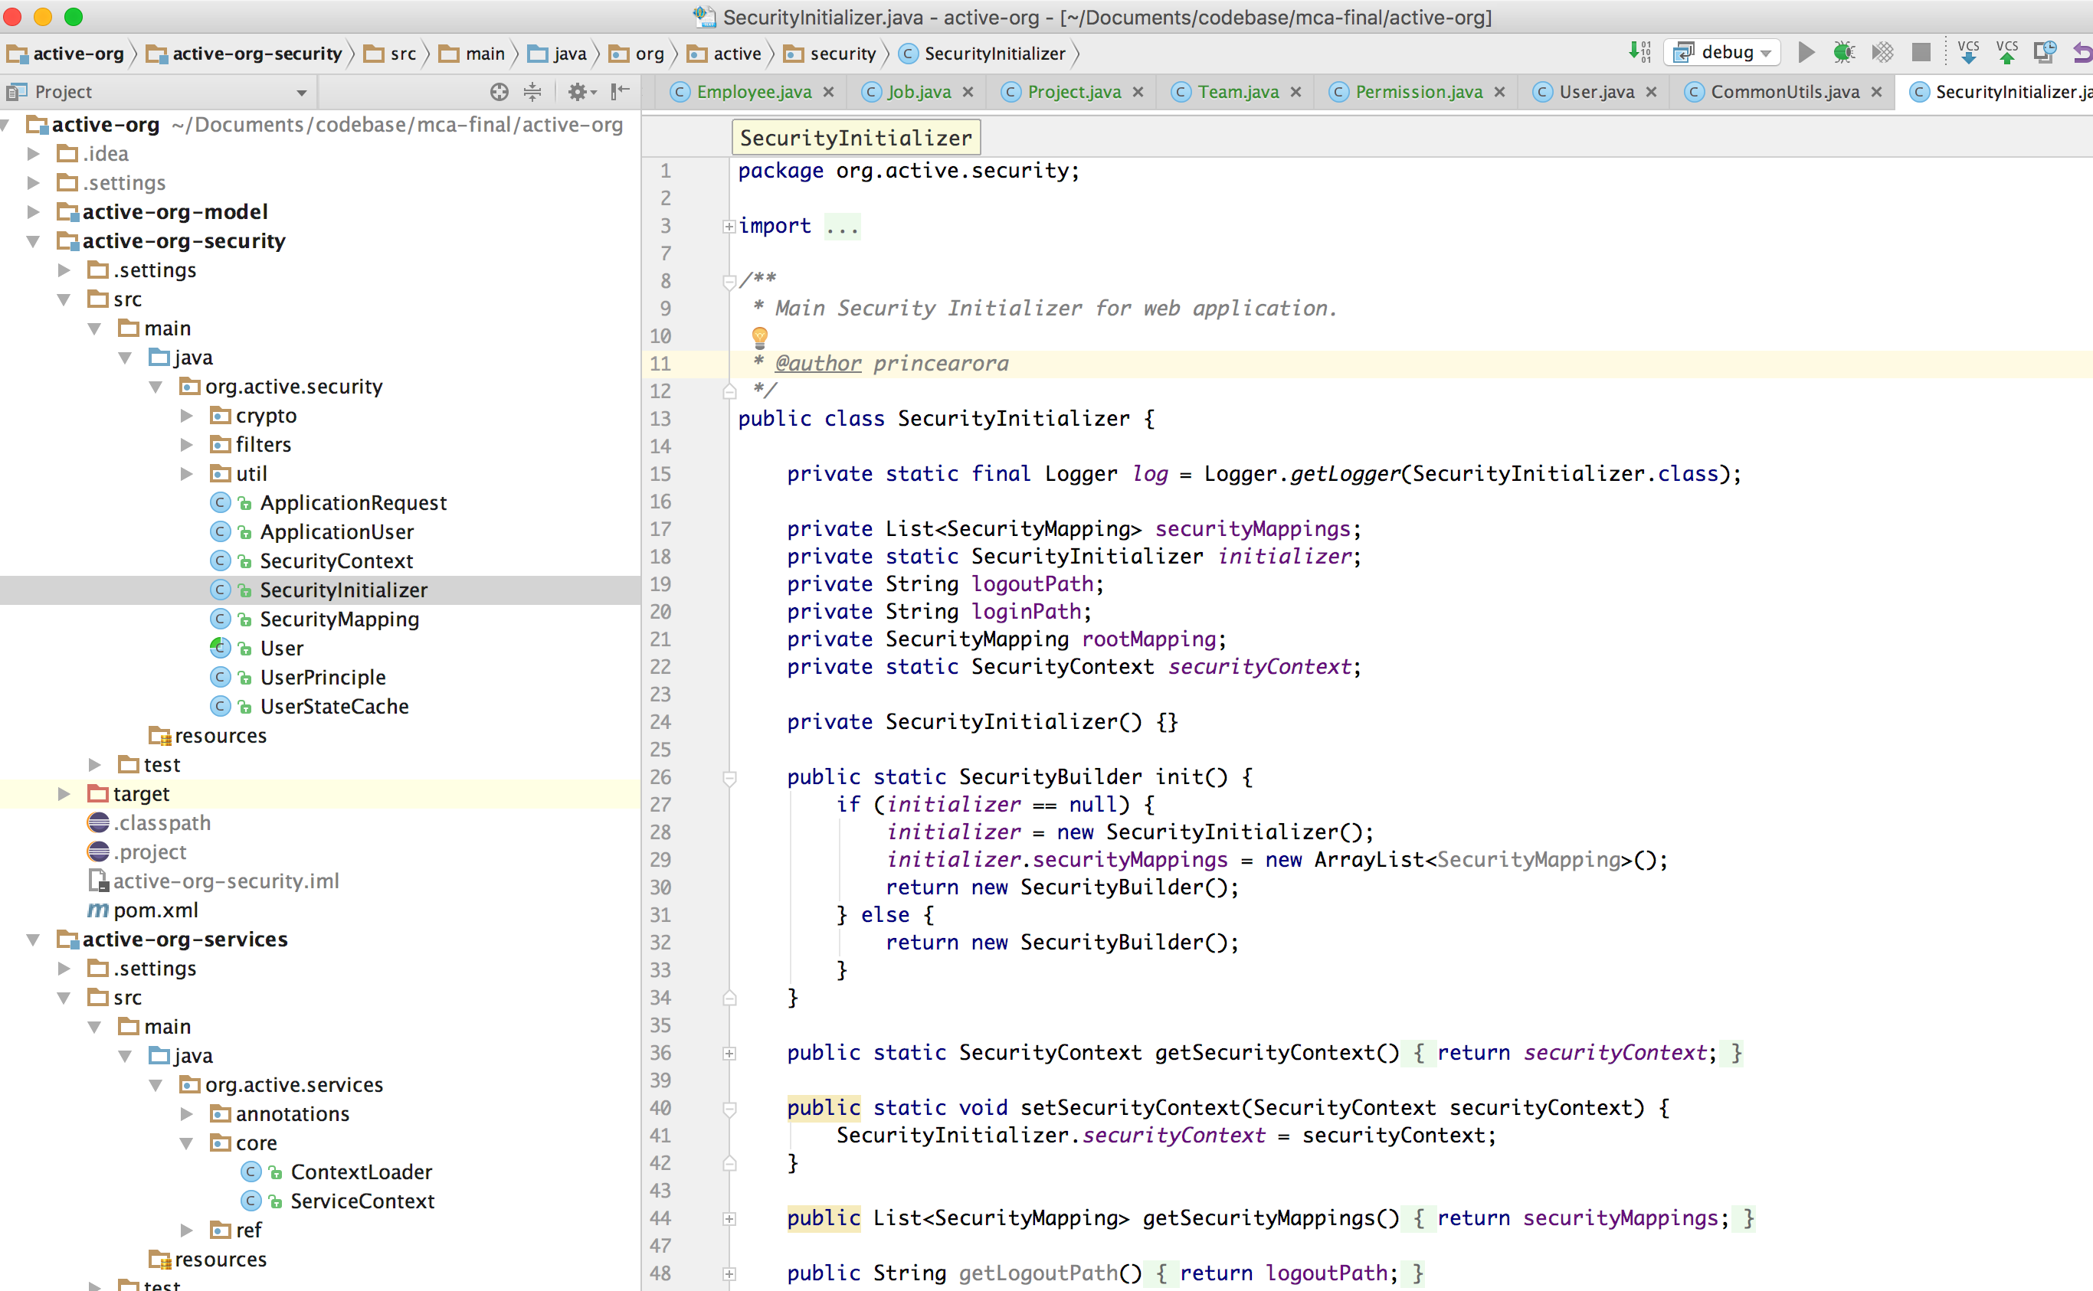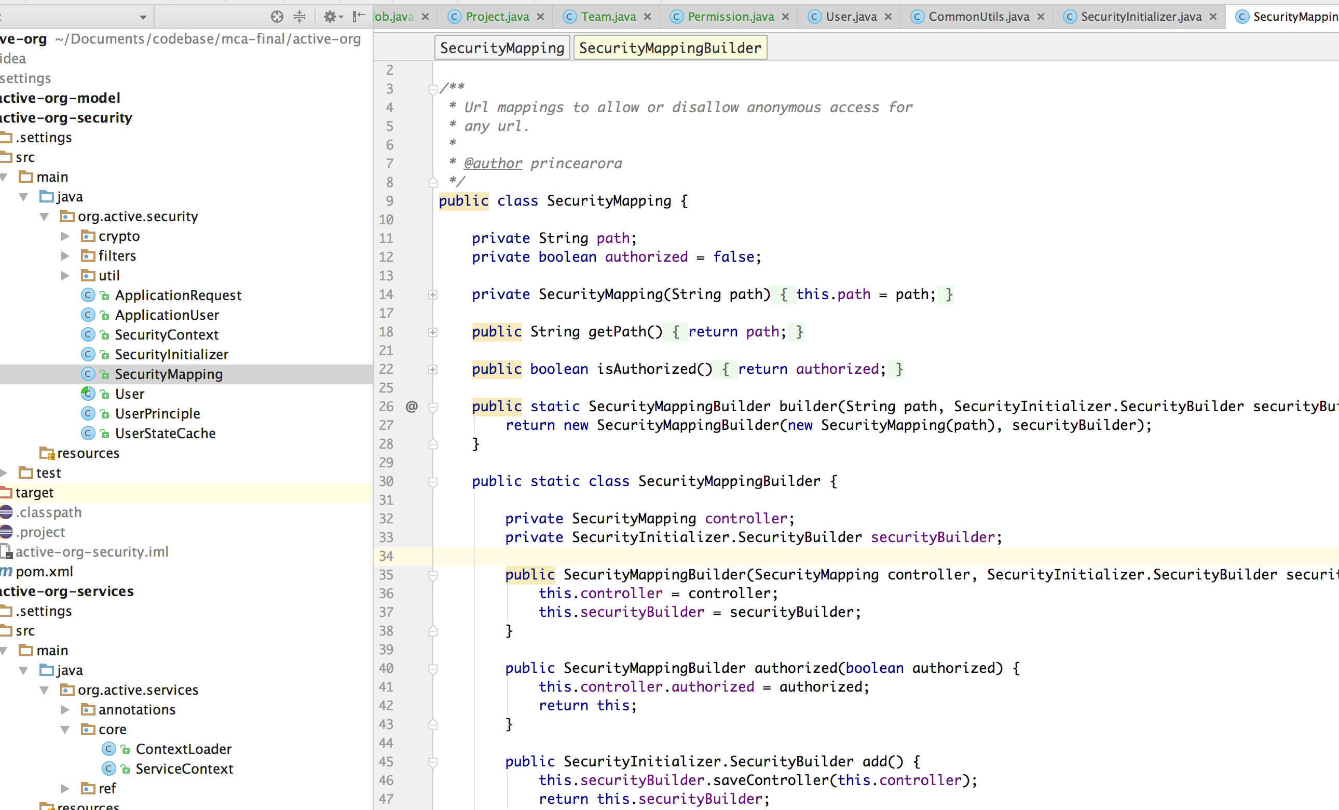rg-security

This module includes filters and utilities for application security. This includes functionality to capture all the urls that should be open to access and also urls that should be open for only logged in users.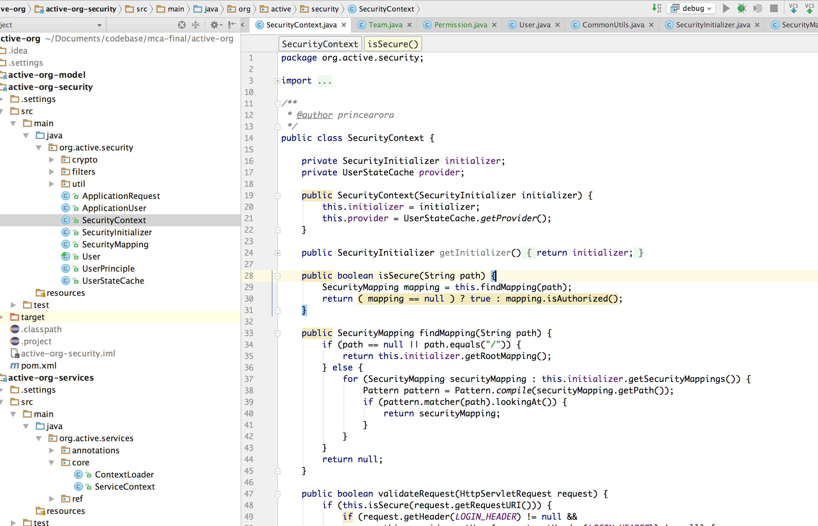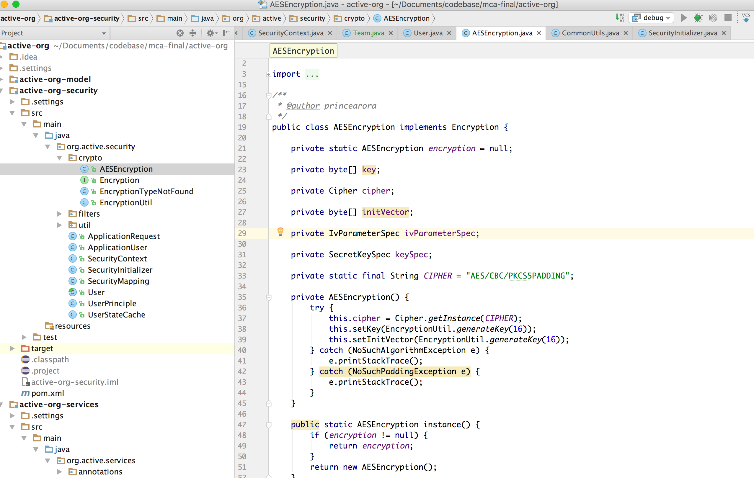

The mail security for urls, starts with SecurityInitializer.java. This defines a singleton instance that maintains all the url configuration and security context to manage logged in users and security status.

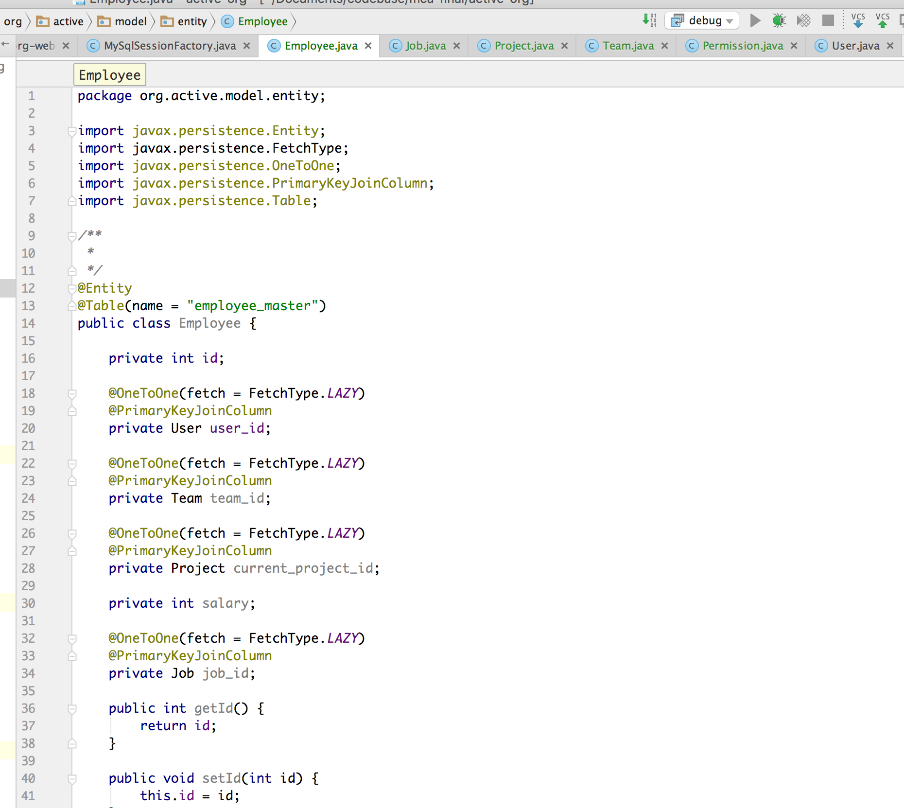

SecurityMapping.java is used to create url mapping configurations and will be kept in a list as a configuration parameter. This will be then used to check for every request.

SecurityContext.java contains all the helper methods and status for users. So to check user status to any request securitycontext instance will be used.

The crypto package contains classes to help for encryption and decryption for token which is generated for users for login process and to check their login status.

AESEncryption.java is used to encrypt user’s information in AES128 Bit encryption algorithm.

Filter package contains filter to validate every request that is coming in. And to validate url from url configuration and if not an open url then check for user token and validate for valid token.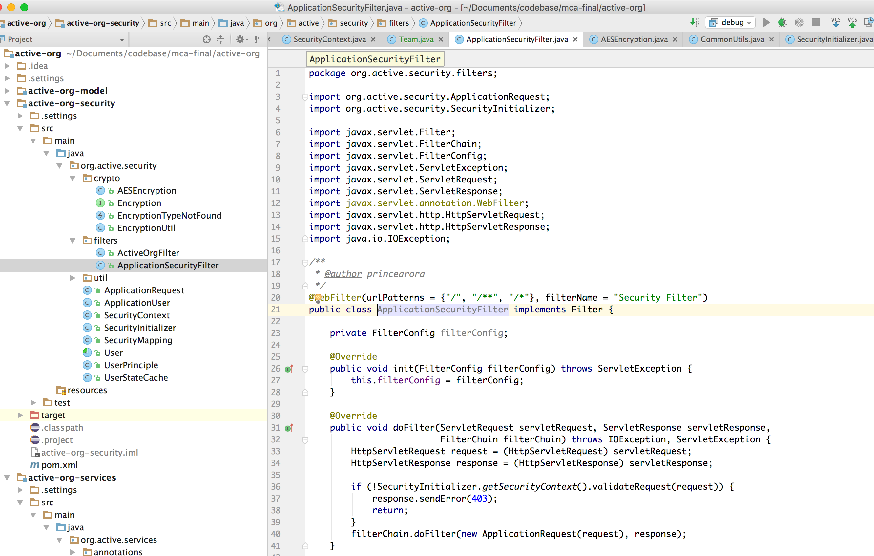

3. active-org-services

This modules contains all the services that are used to execute the mail business logic. These services are scanned at the time of deployment and will be kept in a map data structure. These instances can be retrieved from anywhere in code.

This contains an annotation that will be user to declare a class as service.

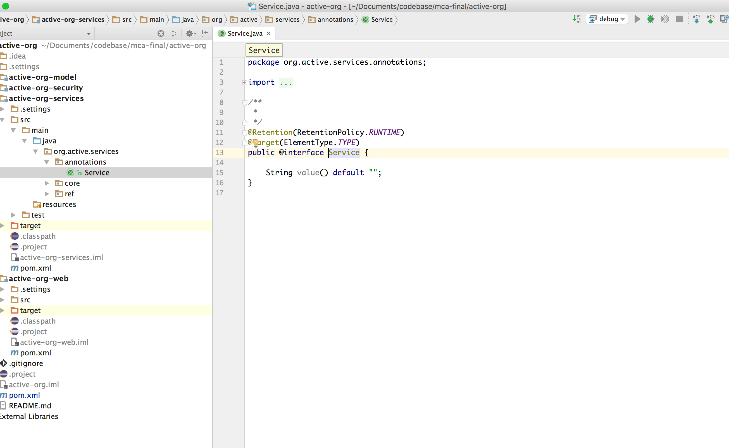

UserService.java is annotated with Service annotation and will be user to perform all the actions related to user table.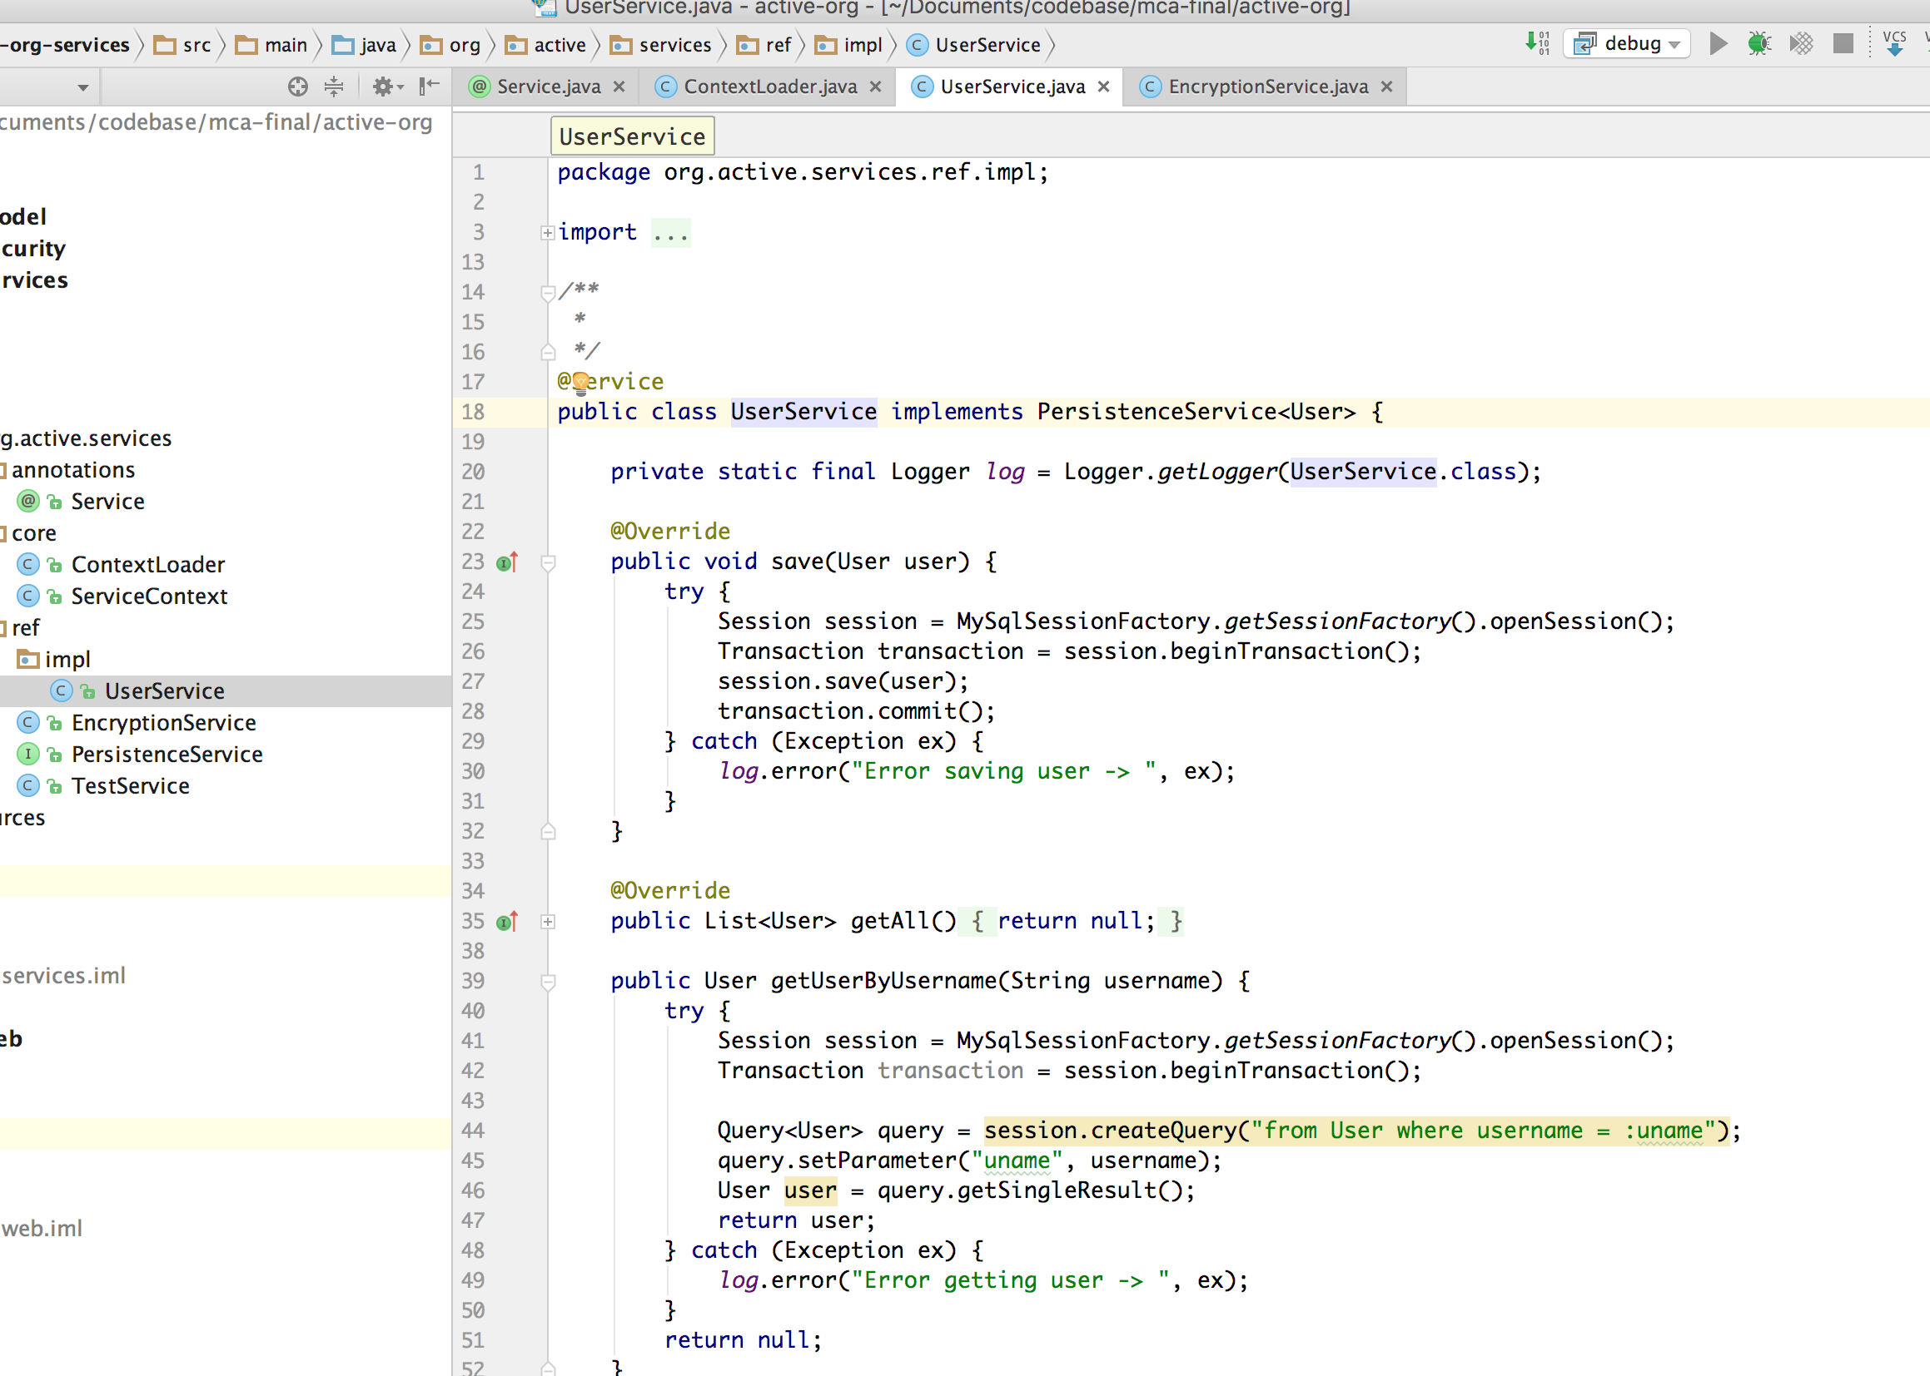

Same as UserService there will be other service implementations for all other entities ex: TeamService, ProjectService, RoleService, MailService etc.

Any of these services can be used in any other class by using below syntax: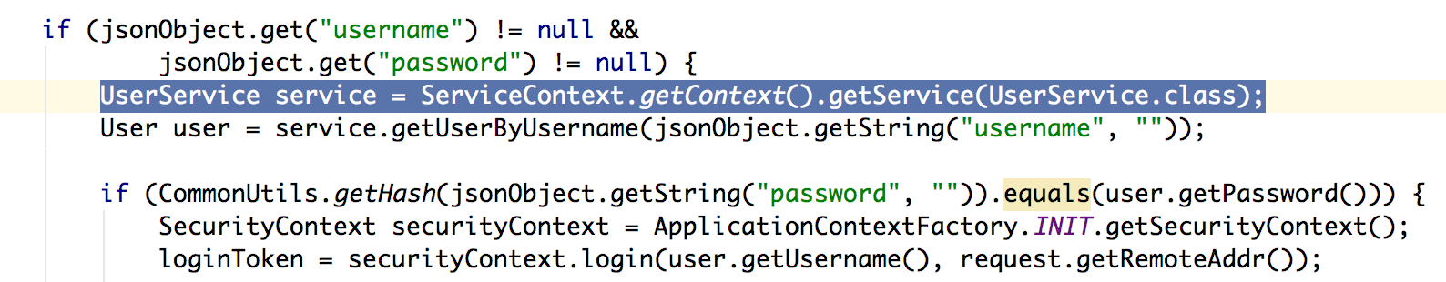

Here we are getting an instance of UserService class got get the user from database.

4. active-org-web

This module contains all the rest service registrations and handling with the request and sending proper response data.

Code for authorisable services to register login, logout etc requests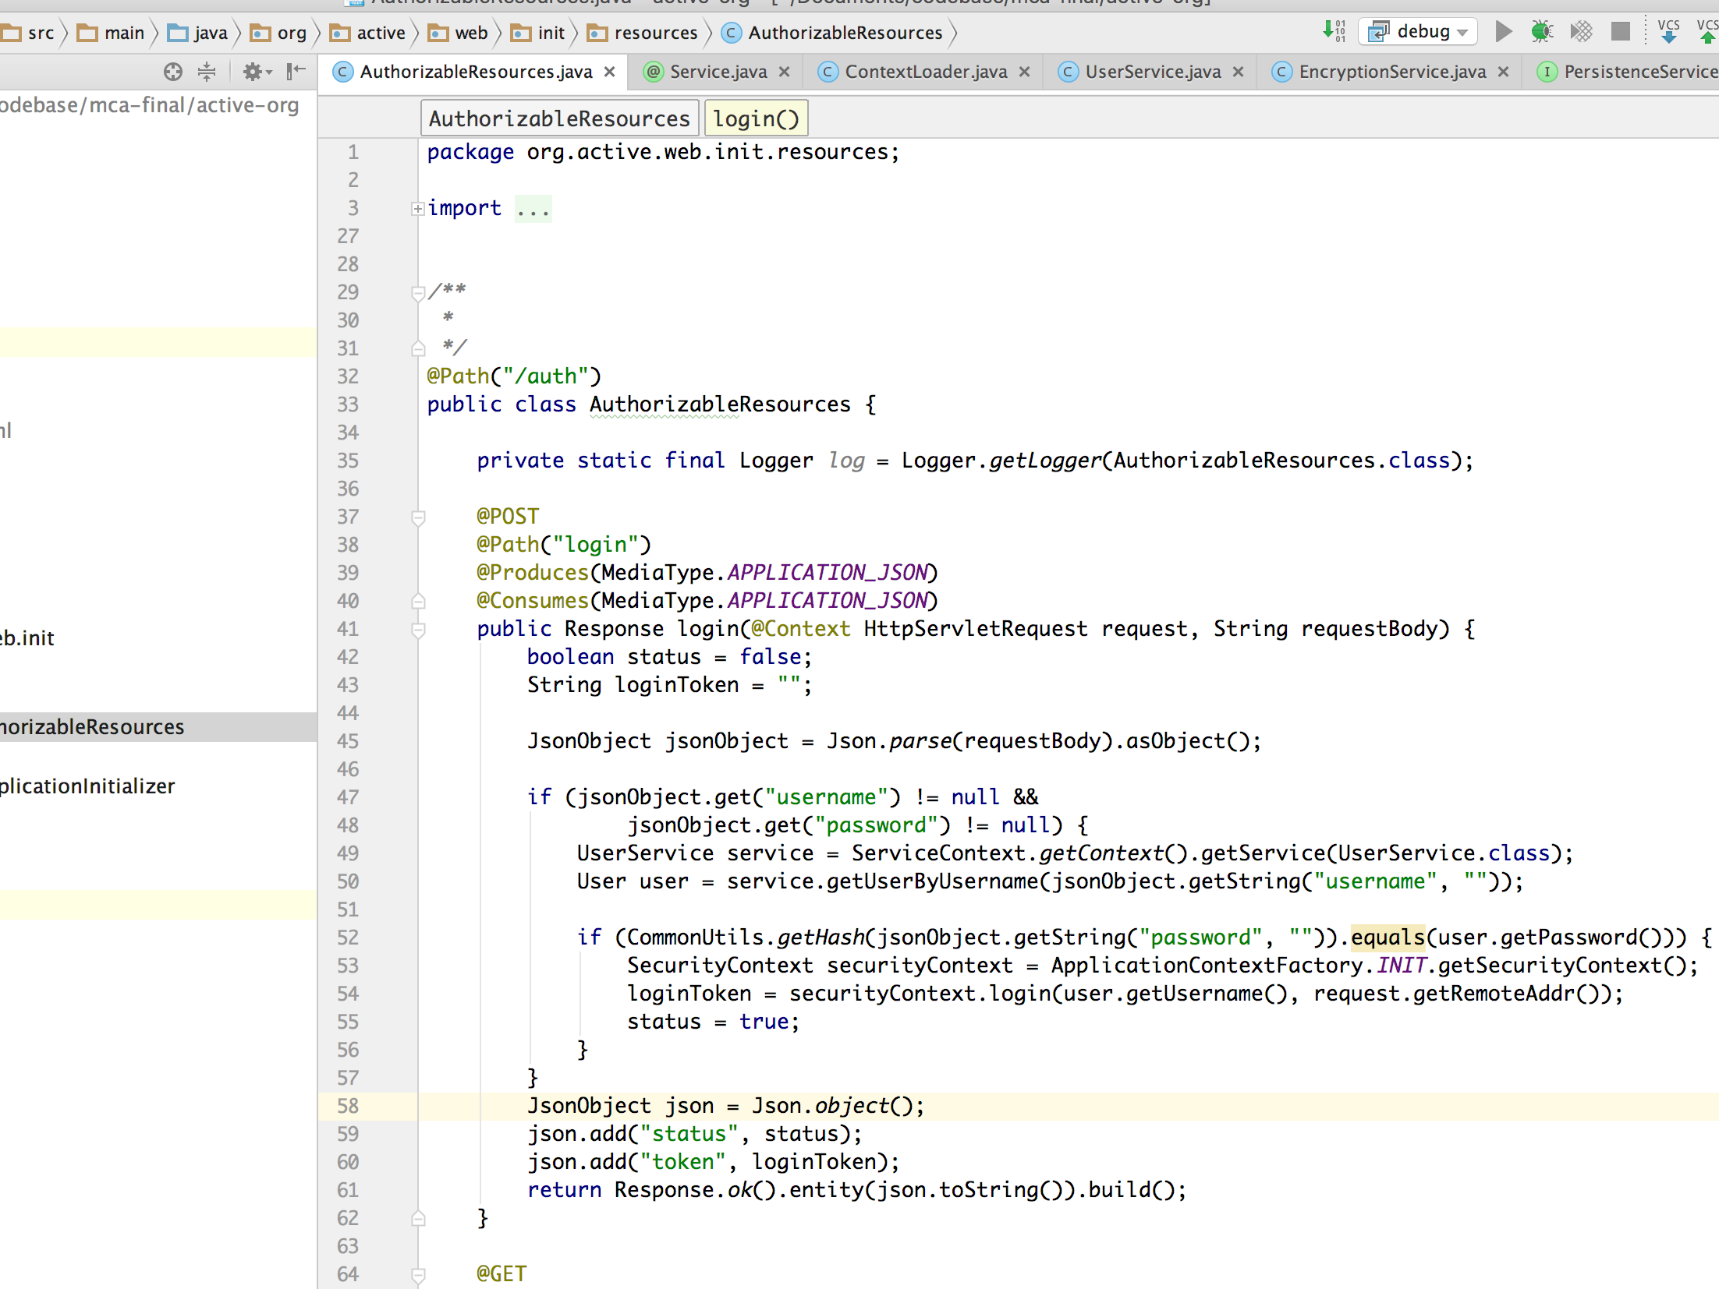

Here we are registering request for login, under resource auth and the request will be a POST as mentioned above login method @POST.

Also we have defined the consume data type and the produce data type to make sure we are sending and receiving all the data as JSON format.

All the other services will be registered like this ex: TeamResource, RoleResource, ProjectResource etc.

WebApplicationInitializer.java is the mail initialiser that implements ServletContainerInitializer which came in java 1.8 and contains one methods

onStartup. Which will be called at the time of deployment. So we are performing all the start up related processes here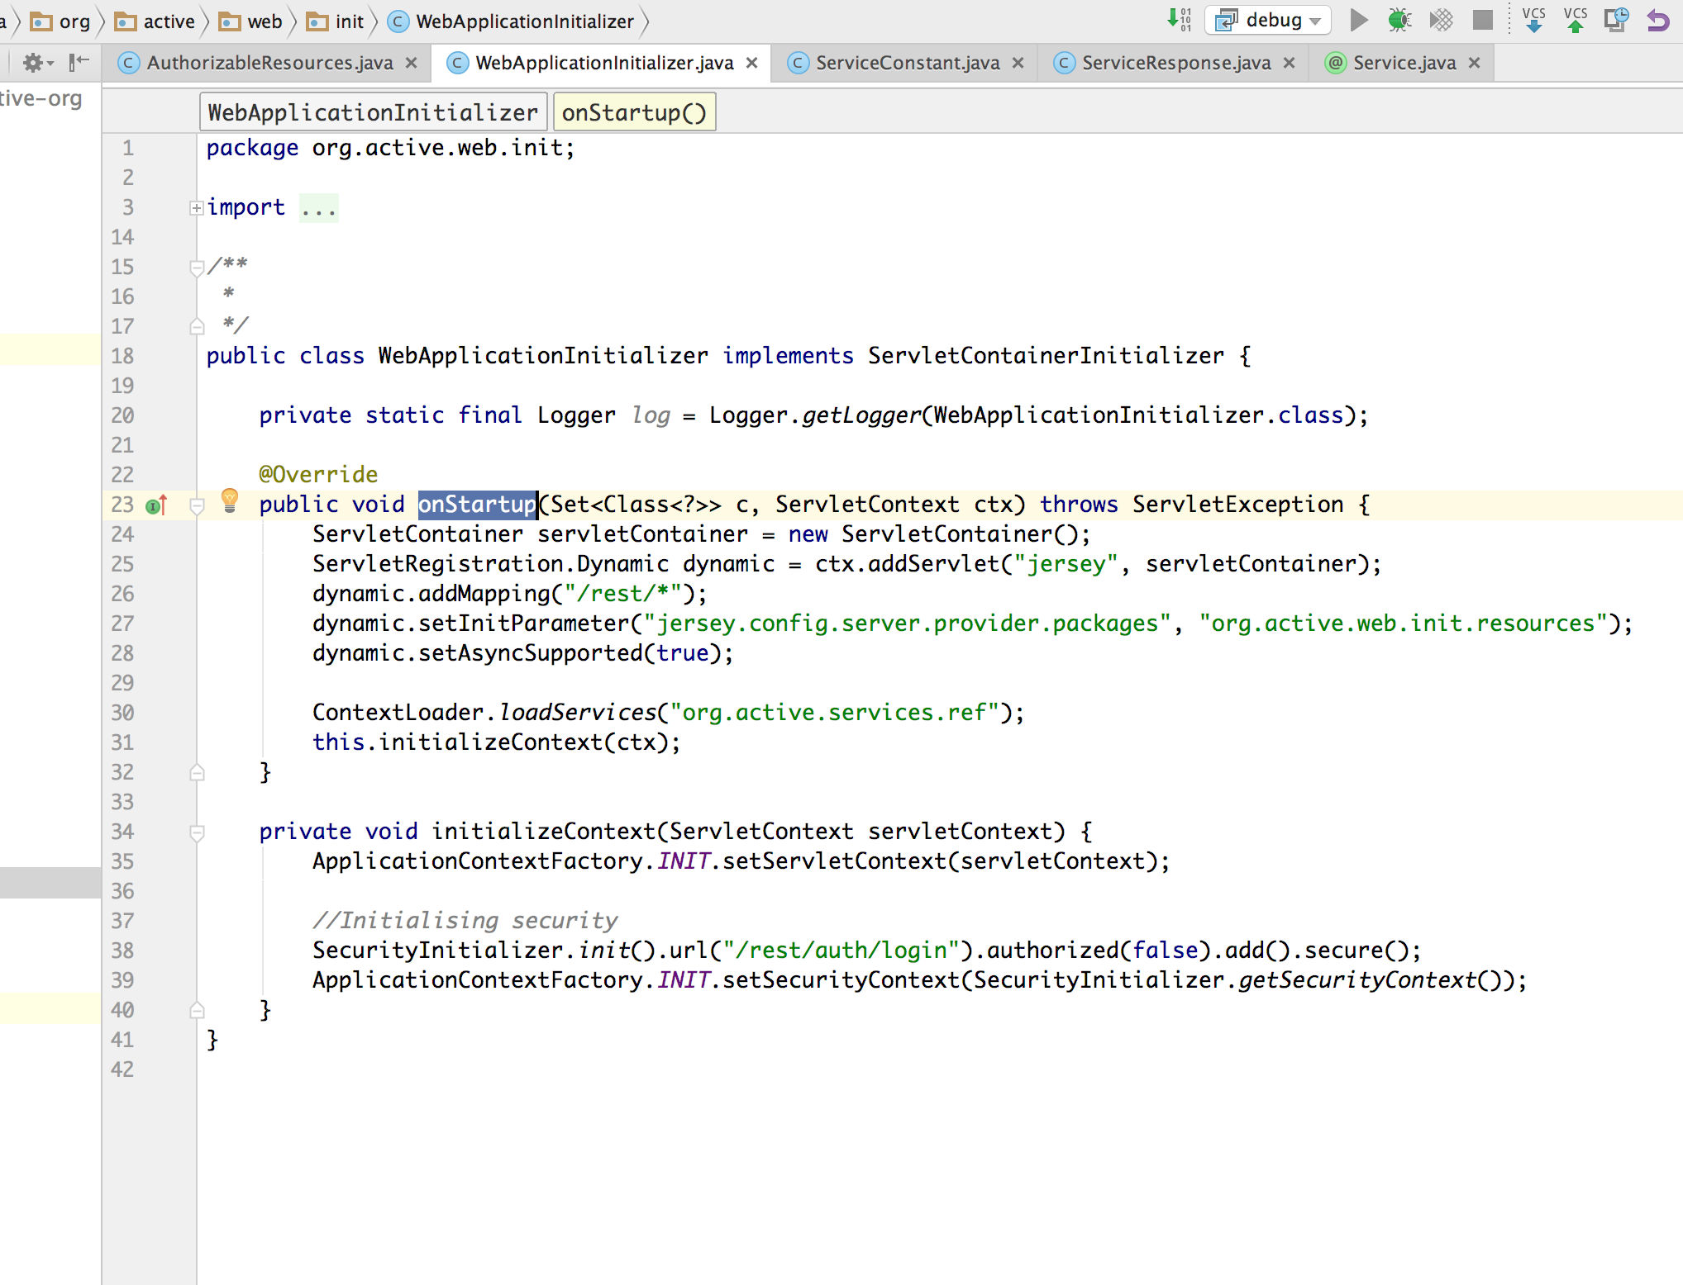

For REST resources we are using Jersey 1.9 that is an implementation for jax-rs. And in initialiser we are registering the dispatcher servlet for jersey at /rest/* so all the requests under this will be handled by jersey and also all the resources/ services we are registering will be accessible after /rest/.

To build and install these modules we just need to run **mvn clean install** from terminal at base location for these modules.

Results

5.1 Input & Output Screens

Login:

Input failed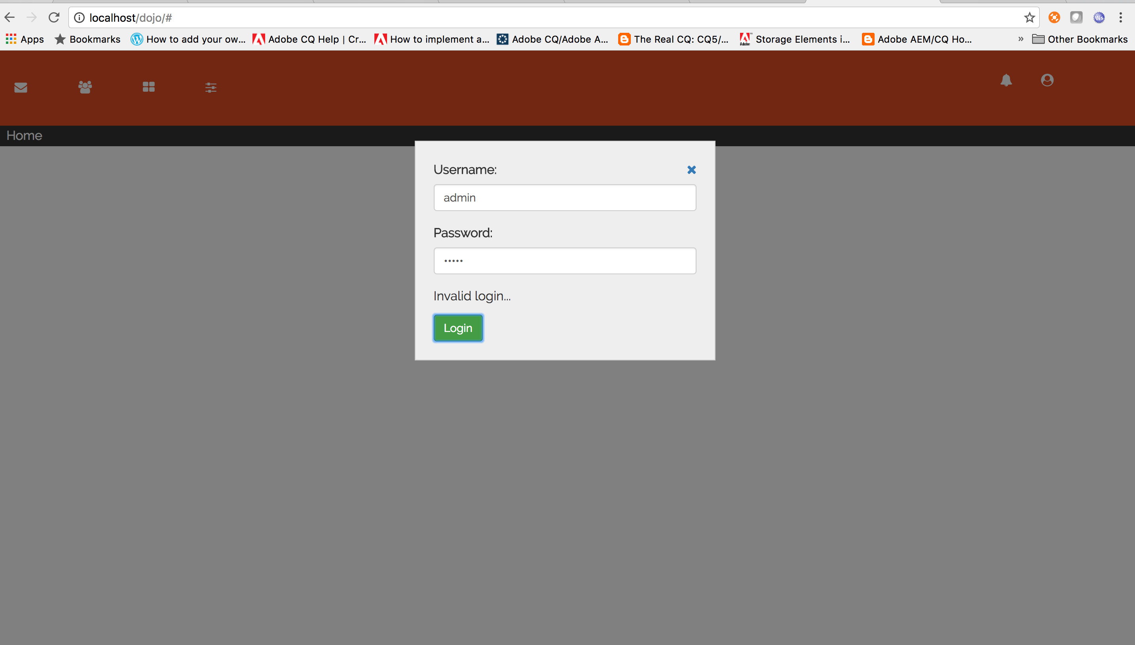

LoginSuccess



Mail Detail View



Assets View:



Team Module View:



Limitations And Future

Limitations:

Limitations for this application will be, it will take a lot of time and resources to build and maintain. As this is a single page application and we are currently loading the data once and using it for all modules. This will impact the performance at time of first page load. After loading the page everything will run smoothly.

Since this is a single page application we cannot use cookies and session based authentication and will be a bit harder to secure this application then other web based application.

I we have have multiple sites then we can divide modules in to different sites and for mobile view we can use these same sites and keep the design as responsive. Responsive design is and representation of the html layout that can understand the view pint and adjust it self according the the device or view port. But is we have all the option at one place then it will be harder to make the design responsive as all the options will be difficult to fit in small view ports.

Future:

Now days most of the applications are running as a single page application and the MVC is coming to frontend instead of backend. That means, Java Scripts frame works/ tool kits are able to handle MVC and we just need technologies like java, c++ python to handle heavy business operations like database query or invalidate data from third party. The number of pages user downloads during visit to my web site?? really how many mails some reads when he/she opens his/her mail account. I read >50 at one go. now the structure of the mails is almost the same. if you will use a server side rendering scheme the server would then render it on every request(typical case). - security concern - you should/ should not keep separate pages for the admins/login that entirely depends upon the structure of you site take paytm.com for example also making a web site SPA does not mean that you open all the endpoints for all the users I mean I use forms auth with my spa web site. - in the probably most used SPA framework Angular JS the dev can load the entire html temple from the web site so that can be done depending on the users authentication level. pre loading html for all the auth types isn't SPA.

Bibliography

MCA Project Semester 6

RESY Services and Single Page Application

<https://en.wikipedia.org/wiki/Representational_state_transfer>

<https://jersey.java.net/documentation/1.18/>

<http://dojotoolkit.org/documentation/>